**Designing A Renewable Energy Based Charging Station for Electric Vehicle**

by

Abu Saleh Md. Raihan

Misbahul Abedin Abid

**BACHELOR OF SCIENCE IN ELECTRICAL AND ELECTRONIC**

**ENGINEERING**



Department of Electrical and Electronic Engineering

INTERNATIONAL ISLAMIC UNIVERSITY CHITTAGONG

July 2023

**Designing A Renewable Energy Based Charging Station For Electric Vehicle**

by

Abu Saleh Md. Raihan

Misbahul Abedin Abid

A thesis/project

submitted as partial fulfilment of the requirement for the degree of

**BACHELOR OF SCIENCE IN ELECTRICAL AND ELECTRONIC ENGINEERING**

Department of Electrical and Electronic Engineering

INTERNATIONAL ISLAMIC UNIVERSITY CHITTAGONG

July 2023

**CERTIFICATE OF APPROVAL**

The thesis/project entitled as **“Designing A Renewable Energy Based Charging Station For Electric Vehicle ”** submitted by **Abu Saleh Md. Raihan** , bearing Matric ID. **ET183044** and **Misbahul Abedin Abid**, bearing Matric ID. **ET183047** of session Spring 2023, to the Department of Electrical and Electronic Engineering, International Islamic University Chittagong, has been accepted as satisfactory in partial fulfillment of the requirements for the degree of Bachelor of Science in Engineering and approved for the examination held on July, 2023.

### Supervisor

### Engr. Sk. Md. Golam Mostafa

Associate Professor

Department of Electrical and Electronic Engineering International Islamic University of Chittagong

**DECLARATION**

It is hereby declared that this work has been done by us and no portion of the work contained in this thesis/project has been submitted elsewhere for the award of any degree or diploma.

____________________

Abu Saleh Md. Raihan

____________________

Misbahul Abedin Abid

**Acknowledgement**

First and foremost, we would like to thank God Almighty for giving us the strength to finish this work. The satisfaction that accompanies the successful completion of this thesis would be in- complete without the mention of the people whose ceaseless cooperation made it possible, whose constant guidance and encouragement crown all efforts with success. We are grateful to our honorable supervisor, **Engr. Sk. Md. Golam Mostafa**, Coordinator, Department of Electrical and Electronic Engineering, International Islamic University of Chittagong, for the guidance, inspiration, and constructive suggestions that were helpful in the preparation of this thesis. He has been our idol and role model in the last couple of months and we are grateful to Almighty Allah for giving us the opportunity to learn under such a great supervisor. Secondly, we would like to express our special thanks to all the faculty members of Department of Electrical and Electronic Engineering, International Islamic University of Chittagong, for giving us comments and invaluable advice for further extension of this thesis. Finally, we would like to thank our family, friends, senior, and juniors of the department for their valuable suggestion and assistance that has helped in successful completion of the thesis.

Author

**Abstract**

Mobilizing and generating economical, environmentally friendly energy resources is one of the key challenges for any nation In the modern world. Thus, energy and power generation are among Bangladesh’s top priorities. Presently, more than 5,00,000 battery powered auto-rickshaws or easy-bikes operate across the country consuming more than 500MW of energy every day. Nevertheless, the rapid growth of EVs and charging stations has worsened voltage quality and harmonic distortion difficulties, compromising the operation of smart-grid electrical transmission networks. Furthermore, with growing concern about the harmful effect of emissions discharged into the environment as a result of vehicles and fossil fuel use, it is critical to move toward alternative means of generating electricity and place greater focus on the development of green technologies. The rapid expansion of modes of transportation in Bangladesh is persuading the government to take action to combat rising CO2 emissions. Because of governments' recent emphasis on renewable energy, the automobile industry is concentrating on creating and distributing more electric and hybrid vehicles as a method of reducing carbon emissions. Appropriate car charging systems are necessary for this. This article demonstrates an integrated electric-vehicle charging station with a battery storage system that operates in the midst of inconsistent wind and solar power sources. The goal is to make it easier to construct an electrical control system that generates the necessary cycle of operation to stabilize and maintain the voltage at the AC/DC power conversion station. Simulations are used to assess the proposed control system's energy management. The suggested method successfully regulates the micro-grid's electric power by taking power form the storage devices at the peak hours and then charging them during off-peak times, decreasing the pressure on the converter and allowing the decrease of time needed to charge for electric cars. A constant voltage is maintained regardless of variations in renewable energy supply or demand.

**TABLE OF CONTENTS**

|  |  |  |  |  |  |
| --- | --- | --- | --- | --- | --- |
| **CERTIFICATE OF APPROVAL** |  |  |  |  | **ii** |
| **DECLARATION** |  |  |  |  | **iii** |
| **ACKNOWLEDGEMENT** |  |  |  |  | **iv** |
| **ABSTRACT** |  |  |  |  | **v** |
| **TABLE OF CONTENTS** |  |  |  |  | **vi** |
| **LIST OF TABLES** |  |  |  |  | **ix** |
| **LIST OF FIGURES** |  |  |  |  | **xii** |

CHAPTER 1 INTRODUCTION 1

* 1. Introduction 1
  2. Background Analysis 1
  3. Research Motivation 3
  4. Thesis Objective 4
  5. Advantages of this project 4
  6. Renewable energy sources 6
     1. Solar Energy 6
     2. Wind Energy 6
     3. Biomass Energy 6

CHAPTER 2 LITERATURE REVIEW 7

* 1. Introduction 7
  2. Review of Previous Work 8

CHAPTER 3 METHODOLGY 13

3.1 Introduction 13

* 1. Literature review 14
  2. Site Selection and Resource Assessment: 14
  3. Renewable Resource For Charging Station 17
  4. Design of the Hybrid Renewable Energy-Based EV Charging Station 25
  5. EV Charging Station Energy Management 26
  6. Electric Vehicle Analysis 28
  7. Energy Demand Of Electric Vehicle 30
  8. Characteristics Of Renewable Charging Station Equipment 31
     1. Photovoltaic Array System 31
     2. Wind Turbine System 32
     3. Biogas Generator 33
     4. System Converter 33
     5. Storage System 34
  9. Simulink Component list 35
     1. Rectifiers 35
     2. PV Array 35
     3. IGBT 36
     4. Repeating Sequence 37
     5. Bus Selector 37
     6. Wind Turbine 38
     7. Permanent Magnet Synchronous Machine 38
     8. Three-Phase V-I Measurement 39
     9. Three-Phase Parallel RLC Load 40
     10. DC BATTERY 41
     11. Charge and Discharge Characteristics 41
     12. DIODE 43

CHAPTER 4 PROCESS MODELING AND SIMULATION 44

* 1. Design of the Hybrid Renewable Energy-Based Electric Vehicle Charging Station 44

4.1.1 General description 44

* + 1. Solar Panels 44
    2. Wind Turbines: 45
    3. Biogas Generator: 45
  1. Design of the Hybrid Renewable Energy-Based Electric Vehicle Charging Station 46
     1. Output of PV 46
     2. Output of the Wind energy-MATLAB model 46
     3. Output of the Biomass MATLAB model 47

CHAPTER 5 RESULT AND DISCUSSION 48

* 1. Introduction 48
  2. Hybrid Power generation in MATLAB simulation 48
  3. Output result of Hybrid Power generation in MATLAB simulation 49
  4. Monthly Electric Production 51
  5. Cost Summary 53
  6. Cash Flow 54
  7. Cost energy of the system 55
  8. Payback 55
  9. Modeling of the Environmental Parameters 55

5.10 Environmental Impact 56

5.11Carbon emission 57

CHAPTER 6 CONCLUSION 59

6.1 Conclusion………………………………………………………………………………..59

6.2 Future Work………………………………………………………………………………59

REFERENCES 60

**LIST OF FIGURES**

* 1. Design of the Grid Hybrid Renewable Energy-Based EV Charging Station 4
  2. SWOT Analysis For EVCS Adoption 8
  3. Architecture of the system for HOMER Pro software (author’s illustration). 10
  4. Connection scheme of Photo-voltaic (PV)/battery energy system (BES)/electric vehicles (EV) charging system. 11
  5. Grid Connected Hybrid Renewable Energy-Based EVCS. 12
  6. Flowchart for proposed methodology 13
  7. Site Location of Hybrid Charging Station 16
  8. Renewable Hybrid Charging Station Site: Mognama Ghat, Cox Bazar 16
  9. 325Watt PV Panel 17
  10. Monthly Average Solar GHI 18
  11. Monthly Average Clearness index 18
  12. Monthly Average Wind speed with Altitude and Anemometer Height 20
  13. 10kw Horizontal axis Wind Turbine 21
  14. Biomass Gasifier 22
  15. Wet weight fraction (%) of municipal solid waste 23
  16. Monthly Average Available Biomass. 24
  17. Block diagram of the Hybrid Renewable Energy-Based EV Charging Station axis Wind Turbine 26
  18. Algorithm used for power management on the EV charging Station 27
  19. 12v Lead Acid battery. 28
  20. Rectifier 35
  21. PV Array 35
  22. Circuit Diagram of PV 36
  23. IGBT 36
  24. IGBT Circuit 36
  25. Repeating Sequence 37
  26. Wind Turbine 38
  27. Permanent Magnet 39
  28. Three Phase V-I Measurement 39
  29. Three-Phase Parallel RLC Load 40
  30. DC BATTERY 41
  31. Charge and Discharge Characteristics 41
  32. Typical Charge Characteristics 42
  33. Exponential Zone 42
  34. Diode 43
  35. Diode Circuit 43
  36. Diode block 43
  37. Solar PV panel 44
  38. Wind Turbine 45
  39. Biomass Gasifier 45
  40. Output curve of PV solar panel 46
  41. Output curve of Wind turbine 46
  42. Output curve of Biomass 47
  43. Hybrid Power generation in MATLAB simulation 49
  44. Output Wave of Wind 49
  45. Output Wave of Solar 50
  46. Output Wave of Biomass 50
  47. Monthly Production 51
  48. Pi chart of Production 52
  49. Nominal power generation capacity of wind/solar/biomass energy resources…………52
  50. Net Present Cost (NPC) 53
  51. Cash Flow 54
  52. Environment emission 57

# LIST OF TABLES

* 1. Clear Index and Solar Radiation Data by Month 20
  2. Average Wind Speed by Month 22
  3. Available Biomass by Month 25
  4. Battery Specification………………………………………………………………… 26
  5. Photovoltaic Array Characteristic 31
  6. Wind Turbine Specifications 32
  7. Specifications of the Generic 100 KW Biogas Genset 33
  8. Characteristics of the System Converter 34
  9. Characteristics of the Battery 35
  10. Total Electricity Production by Renewable Sources 52
  11. Component Costs 54
  12. Table for Payback Year 59

# LIST OF ABBREVIATIONS

|  |  |
| --- | --- |
| EVCS | Electric Vehicle Charging station |
| RES | Renewable energy sources |
| WT | Wind turbine |
|  |  |
|  |  |
|  |  |
|  |  |
|  |  |
|  |  |
|  |  |
|  |  |
|  |  |
|  |  |
|  |  |
| PV | Photovoltaic |
|  |  |
| WPU | Wind power unit |
|  |  |
| WEC | Wind energy converter |
|  |  |
| SPV | Solar Photo Voltaic |
|  |  |
| HRES | Hybrid renewable energy systems |
|  |  |
| GHG | Greenhouse gas |

|  |  |
| --- | --- |
|  |  |
|  |  |

**CHAPTER 1**

**INTRODUCTION**

* 1. **Introduction**

Due to governments’ recent emphasis on renewable energy, the automobile industry is working on creating and distributing more electric and hybrid automobiles in order to minimize carbon emissions. Appropriate car charging systems are necessary for this. To realize the maximum potential of renewable energy, a hybrid power production system combines two or more natural resources. A hybrid PV-Wind-Biomass system combines solar energy, wind energy, and a biomass generator to create electricity from all sources at the same time or separately depending on need. A hybrid- based electric vehicle (EV) charging station that uses renewable energy sources such as solar, wind, and biomass will be long-term sustainable. Rapid urbanization and rising transportation demand have resulted in considerable increases in greenhouse gas emissions and energy consumption. To overcome these issues, integrating renewable energy into EV charging infrastructure may offer sustainable and environmentally friendly mobility alternatives. The suggested hybrid charging station aims to enhance renewable energy use while providing dependable and efficient charging services.

# Background Analysis

The energy demand in Bangladesh has been rising significantly over the last decade because of the most common form of energy. To meet this ever-growing demand, we need to think of the most sustainable energy generation system which is Hybrid power generation. The hybrid power generation system in a hybrid combination of two or more natural resources to gain the full potential of renewable energy. Hybrid PV-Wind-Biomass system is the combination of Solar energy, Wind energy and Biomass generator to generate power from all sources simultaneously or separately per demand. With the help of government legislation, the ownership of electric vehicles (EV) has expanded dramatically in recent years. The bulk of transportation vehicles are now powered by a combustion engine. This combustion engine has an efficiency rating of 25-30% [1]. Electric vehicles, on the other hand, are up to 85% more efficient due to superior motor efficiency [2]. However, the difficulty of locating electric vehicle charging stations (EVCSs) is worsened by the immaturity of charging facility design and the availability of distributed renewable energy sources and storage technology. As a result, there is often an imbalance between charging demand and power supply. On the one hand, charging terminals often fail to meet the ever-increasing charging demand, leaving EV owners with no place to charge or with long charging lines. On the other hand, some charging stations are underutilized or even dormant,

which has a negative influence on the growth of EVs. [3] Furthermore, EVs are regularly linked to the grid when charging. A significant number of charging behaviors in a short period of time cause the grid load to grow rapidly, which accentuates grid voltage fluctuation and has a negative influence on power system stability. As a consequence, developing an interaction link between the distribution network and EV charging facilities is a significant difficulty that must be addressed in the current EV charging facility layout design. With growing concern about the harmful effect of emissions from automobiles and fossil fuel use on the environment, it is critical to transition to alternative means of generating electricity and place more focus on the development of green technologies. [4] The increasing proliferation of modes of transportation in Bangladesh - a nation with 20 lacs automobiles with little monitoring - is persuading the government to take action to combat rising CO2 emissions [5]. The statistics presents, demand for transportation will increase by 54% by 2035 [6]. The National Transportation Research Center (NTRC) estimates that worldwide burns 27706.5 trillion BTU (British thermal unit) annually for transportation and produces about 6.6 GT carbon dioxide (CO2) [7]. EV, on the other hand, is environmentally friendly and quiet. Bangladesh, being a developing nation, contributes to world GHG levels, i.e., is a CO2 emitter. In Bangladesh, per-person CO2 emissions ranged from 0.46 metric tons in 1972 to 2014.

GHG emissions in Bangladesh are largely produced by the transportation sector. substantial

amount of these GHG CO2 is the gas emitted. According to figures from the World Energy Council, transportation-related GHG emissions account for about 17% of total emissions [8]. Given governments' recent emphasis on renewable energy, the automobile industry is concentrating on creating and distributing more electric and hybrid vehicles as a method of reducing carbon emissions. Appropriate car charging systems are necessary for this. This study describes the design and optimization of a hybrid-based electrical vehicle (EV) charging station in Bangladesh that uses renewable energy sources such as solar, wind, and biomass for grid connection. The country’s rapid urbanization and increasing demand for transportation have led to a significant rise in greenhouse gas emissions and energy consumption. To address these challenges, the integration of renewable energy into the EV charging infrastructure can provide sustainable and eco-friendly transportation

solutions. The proposed hybrid-based charging station aims to maximize renewable energy utilization while ensuring reliable and efficient charging services.

# Research Motivation

The most frequent energy source has increased Bangladesh’s energy consumption during the previous decade. Hybrid power production is the most sustainable way to address this expanding demand. Government policy has greatly increased EV ownership. Most transportation vehicles use combustion engines. This combustion engine is 25-30% efficient. Due to motor efficiency, EVs are 85% more efficient [9]. The lack of maturity in charging station design, as well as the availability of distributed renewable energy sources and storage technologies, makes EVCSs more difficult to locate. So, charging demand frequently exceeds power supply. On the other hand, charging stations sometimes fail to meet the growing demand, leaving EV users without a place to charge or in long lines. However, some charging infrastructures are underutilized or dormant, which hinders EV adoption. EV charging often involves grid connection. A significant number of charging actions in a short time would raise grid demand unexpectedly, intensifying grid voltage fluctuation and threatening power system stability. Thus, EV charging facility layout design must address the distribution network-EV charging facility interaction. With growing concern about the environmental effect of automotive and fossil fuel emissions, it is crucial to switch to alternative power sources and focus on green technologies. This study describes the design and optimization of a hybrid-based electrical vehicle (EV) charging station in Bangladesh that uses solar, wind, and biomass for energy generation and battery storage for storing excess energy [10]. Renewable energy in EV charging infrastructure can solve these problems. The proposed design is shown in **Fig. 1.1** maximizes renewable energy use while providing stable and efficient charging services.

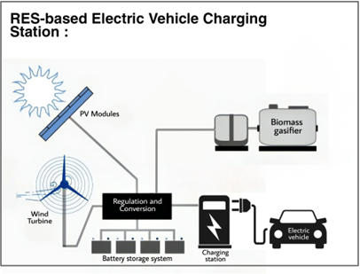

**Fig. 1.1:** Hybrid Renewable Energy-Based EV Charging Station Design

# Thesis Objective

1. To assessment of the potential of a renewable resource for charging station.
2. To design a PV-Wind-Biomass hybrid framework with battery storage system.
3. Economic and environmental effect analysis of this hybrid power generation system.

# Advantages of this project

* + 1. ***Renewable Energy Utilization:*** The project harnesses solar, wind, and biomass energy resources, enabling a significant reduction in carbon emissions associated with traditional fossil fuel-based transportation. This promotes a cleaner and greener environment.
    2. ***Energy Security*:** Bangladesh may minimize its reliance on imported fossil fuels by relying on renewable energy sources, therefore improving energy security and lowering susceptibility to variations in global oil prices.
    3. ***Cost Savings:*** Utilizing renewable energy can help mitigate the rising costs of conventional energy sources. The project can lead to cost savings in the long run, as solar, wind, and biomass energy are sustainable and require minimal operational expenses once the infrastructure is established.
    4. ***Grid Reliability and Resilience:*** The hybrid charging station can increase the stability and reliability of the power grid by decentralizing energy production and diversifying energy sources. It provides an alternative source of electricity during grid outages or disruptions.
    5. ***Local Job Creation:*** The development, installation, and maintenance of the hybrid charging station can create employment opportunities within the renewable energy sector, contributing to economic growth and job creation in Bangladesh.
    6. ***Public Health Benefits:*** Shifting towards electric vehicles powered by renewable energy helps mitigate air pollution and its associated health risks. The project can contribute to improved air quality and public health outcomes by reducing emissions from conventional vehicles.
    7. ***Scalability and Adaptability:*** The hybrid charging station design can be replicated and scaled up across different locations in Bangladesh, accommodating the growing demand for electric vehicles and supporting the expansion of sustainable transportation infrastructure.
    8. ***Technological Advancement:*** Implementing a hybrid-based charging station demonstrates Bangladesh’s commitment to embracing advanced green technologies. It encourages re- search, development, and innovation in the renewable energy sector, fostering technological advancements within the country.
    9. ***International Reputation and Cooperation:*** By promoting sustainable transportation and renewable energy integration, the project can enhance Bangladesh’s international reputation as a forward-thinking and environmentally conscious nation. It also opens avenues for collaboration with international organizations and governments focused on renewable energy and climate change mitigation.
    10. ***Climate Change Mitigation:*** The project contributes to national and global efforts in mitigating climate change by reducing greenhouse gas emissions and promoting the adoption of sustainable energy solutions. Bangladesh’s commitment to green technology can inspire and motivate other countries to follow suit in transitioning towards low-carbon transportation systems.

# Renewable energy sources

The global reliance on finite fossil fuels for energy production poses significant challenges due to resource depletion, environmental pollution, and greenhouse gas emissions. However, renewable energy sources such as solar, wind, hydro power, and ocean energy offer sustainable alternatives that are environmentally friendly, do not deplete, and have the potential to meet the world’s energy demands indefinitely.

## *Solar Energy*

Solar energy, derived from the sun, is a potent and versatile source of power. Solar panels, which are made up of unique cells that absorb the sun's rays and transform them into useful power, can be used to harvest solar energy. By utilizing solar energy, we can heat water for household use, illuminate our homes and streets, power electronic devices, and even contribute excess electricity back to the grid, decreasing our dependency on nonrenewable energy sources and our carbon impact [11].

## *Wind Energy*

Wind, a natural and freely available resource, can be transformed into a valuable source of electricity through the use of wind turbines. These massive structures absorb the kinetic energy of the wind and turn it into electrical power [12]. Harnessing wind energy allows us to generate electricity on a large scale, powering homes, businesses, and even entire communities. Wind energy is a sustainable solution that reduces greenhouse gas emissions, promotes energy independence, and supports rural development by creating jobs in manufacturing, installation, and maintenance of wind turbines.

## *Biomass Energy*

Biomass, derived from organic materials such as wood, crops, agricultural residues, and organic waste, offers a versatile and renewable source of energy. Through processes like combustion, classification, or fermentation, it can be converted into heat, electricity, or bio fuels. Biomass energy is a valuable alternative to fossil fuels, as it can be sustainably produced from agricultural and forestry by-products, reducing waste and utilizing materials that would otherwise decompose and release greenhouse gases [13]. By harnessing biomass energy, we can reduce our reliance on fossil fuels, mitigate climate change, and promote a circular economy by utilizing organic waste materials.

**CHAPTER 2**

**LITERATURE REVIEW**

# Introduction

Providing more awareness about the harmful effect of pollutants emitted into the environment by automobiles and fossil fuel use, it is critical to move toward alternative means of generating electricity and put more focus on the development of green technologies. The growing expansion of modes of transportation in Bangladesh, a nation with 20 lacs automobiles and no monitoring, is persuading the government to take action to combat rising CO2 emissions [14]. The national grid must offer more than 500 MW per day due to the surplus power necessary to recharge these EVs [15]. The integration of electric vehicle into the electrical grid brings new challenges, such as thermal constraint violation of transmission lines due to overload, voltage loss in particular essential network busses, and unpredictability of demand [16]. In light of governments' recent emphasis on renewable energy, the automobile industry is working on creating and distributing more electric and hybrid vehicles in order to minimize carbon emissions. Appropriate car charging systems are necessary for this. The hybrid power generation system in a hybrid combi- nation of two or more natural resources to achieve the full potential of renewable energy. Hybrid PV-Wind-Biomass system is the combination of Solar energy, Wind energy and Biomass generator to generate power from all sources simultaneously or separately per demand. A hybrid-based electrical vehicle (EV) charging station that utilizes renewable energy sources, including solar, wind, and biomass will be sustainable in the long term. The country’s rapid urbanization and increasing demand for transportation have led to a significant increase in greenhouse gas emissions and energy consumption [17].

To address these challenges, the introduction of green energy into the EV charging infrastructure can provide sustainable and eco-friendly transportation solutions. SWOT analysis for EVCS adoption is shown in **Fig. 2.1**. The proposed hybrid-based charging station seeks to maximize renewable power utilization while remaining sustainable and efficient charging services. To address these challenges, the integration of renewable energy into the EV charging infrastructure can provide sustainable and eco-friendly transportation solutions. The proposed hybrid-based charging station seeks to maximize renewable energy utilization while ensuring reliable and efficient charging services.

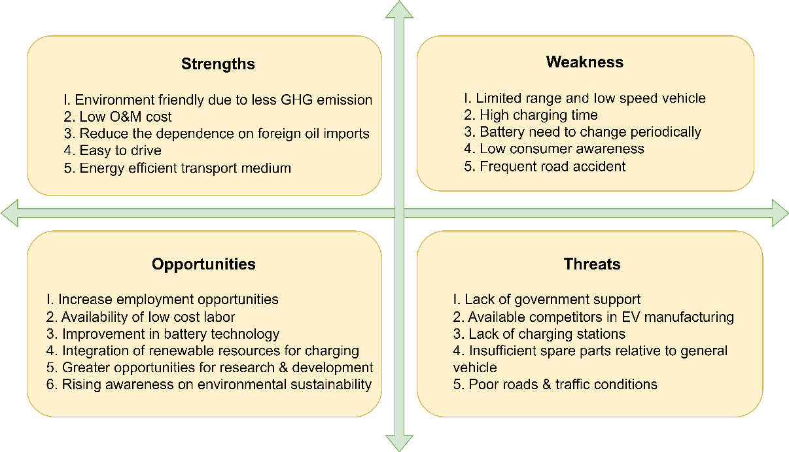 **Fig. 2.1**: SWOT analysis for EVCS adoption

# Review of Previous Work

Coupling between sources of clean energy with energy storage systems is critical for overcoming the issues associated with renewable energy's intermittent nature. While various energy storage options have been explored, there is a lack of studies focusing on suitable solutions for developing countries like Bangladesh. This literature review aims to contribute to the existing body of knowledge by examining the utilization of renewable energy sources as energy options to power up charging station for electric vehicles. It also discusses the potential benefits, simulation results, and implications of such a system. The majority of the publications concentrated on the impact of charging PEVs on the grid and features of EVCS design, ignoring the economic viability of this expenditure. It is necessary to investigate how the EVCS can be operated as an isolated microgrid while considering multiple supply options such as renewable energy resources, as well as as a smart energy hub [18]. By reviewing previous articles, it was discovered that concurrently suitable site and energy demand calculation for renewable energy based charging station and EV charging schedule had not been completed. Furthermore, the aim of the work is simply described as single or dual objective, and the majority of them have worked in the field of minimizing losses and expenses. In other papers, a single EV model is used for transport section modeling, and the EV owner's behavior, EV specifications, and expenditures related to the vehicle's battery are neglected.

### Electric Rickshaw Charging Stations as Distributed Energy Storages for Integrating Intermittent Renewable Energy Sources: A Case of Bangladesh

This exploratory study describes a potential way to use electric vehicle as a catalyst to increase Bangladesh’s proportion of renewable energy sources. The primary purpose of this research is to show how to leverage a pre-existing opportunity, such as electronic rickshaws as storage options for combining sources of clean energy. It recommends employing an e-rickshaw battery swapping charging station (BSCS) as a community-based battery-powered energy storage system (CBESS) for a grid-dependent local energy system. Software called HOMER Pro was used to mimic this system. Architecture of the system that is shown in **Fig. 2.2** demonstrate that by incorporating local solar PV, such systems may dramatically lessen communities’ reliance on the national grid. The suggested BSCS also demonstrates a chance to reduce battery consumption and implement circular battery management for electric vehicle. The study also covers the economies of scale of the suggested approach in Bangladesh and the implementation processes for microgrids and smart energy systems. By utilizing local opportunities to provide an alternative energy storage option, the novel notions offered in this re- search will initiate policy-level discussion in Bangladesh and give the researchers motivation for more research. This literature review emphasizes the potential of utilizing electric rickshaws as energy storage options in Bangladesh to increase the share of renewable energy. The integration of battery swapping and charging stations within a grid-connected local energy system offers multiple benefits, including reduced reliance on the national grid, circular battery management, and increased utilization of solar PV power. By addressing the existing knowledge gaps and exploring pathways for implementation, this research contributes to the ongoing efforts to foster renewable energy integration and promote sustainable energy systems in Bangladesh.

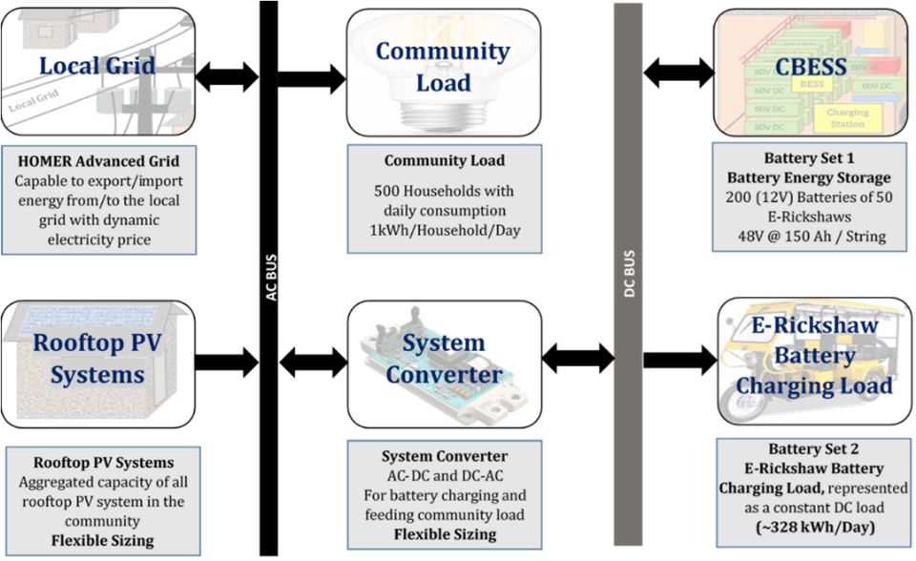

**Fig. 2.2:** Architecture of the system for HOMER Pro software (author’s illustration) [18].

### Grid-connected hybrid renewable energy systems for supermarkets with electric vehicle charging platforms: Optimization and sensitivity analyses

The energy and transportation sectors must be integrated for the best use of renewable energy. The current study suggests a grid-connected photovoltaic/ wind/ battery hybrid power system to supply supermarkets with electricity. There are supermarkets in three geographically separate cities in Moroccan parking lots now include EV (electric car) charging points. The suggested hybrid renewable energy system (HRES) is designed with the best utility tariff possible in accordance with the Moroccan situation using the HOMER grid software. Dakhla, a high windy site, is chosen to be the most effectively implemented site with the highest environmentally friendly energy percentage (REF), minimal COE, and operating expenses of 71.66%, 0.0841 $/kWh, and 0.124 M$/year, respectively. The ideal grid-connected solution for the Dakhla site included 12 batteries, a 65 kW capacity inverter, 300 kW of wind power, and 107 KW of solar power. Based on COE and annual running costs, Casablanca is the next best site, while Fez is still in third place. With 7300 charging sessions each year, the EV charging procedure is practically entirely completed at each of these locations. Based on the energy intensity of supermarkets, the availability of renewable energy, and the price of car- bon, a number of sensitivity studies were conducted, and the impact on the feasibility of HRES was demonstrated. The transition towards clean and renewable energy sources has become a global

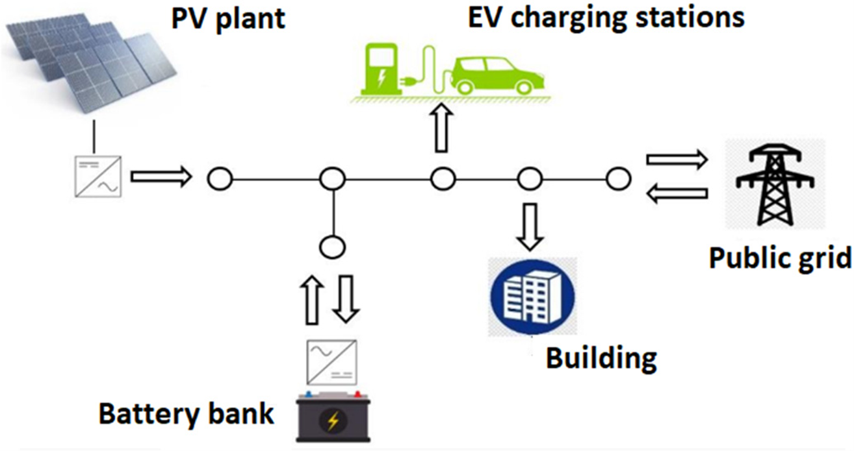priority due to increasing energy demands, environmental concerns, and the need to mitigate cli- mate change. This review addresses a research study that proposes the installation of a grid-connected photovoltaic/wind/battery hybrid power system to generate electricity for Moroccan supermarkets while incorporating electric vehicle (EV) charging stations in their parking areas, as shown in **Fig. 2.3**. The objective of this review is to assess the feasibility and viability of coupling hybrid renewable energy systems with EV charging infrastructure at supermarkets.

**Fig. 2.3:** Connection scheme of Photo-voltaic (PV)/battery energy system (BES)/electric vehicles (EV) charging system*.* [19].

### Challenges for Electric Vehicle Adoption in Bangladesh

Electric vehicles (EVs) provide a new dimension to the transportation industry while also using a significant amount of electricity. Although it gains a lot of popularity since it reduces the consumption of fossil fuels, improves environmental sustainability through low GHG emissions, reduces noise pollution, and is a cost-effective mode of transportation. However, a number of obstacles make EV adoption in Bangladesh exceedingly difficult. In the context of Bangladesh, this article sought to investigate potential issues that would provide obstacles to the adoption of EVs. This study uses SWOT analysis to examine EV penetration. This report also suggests a number of strategies to address the difficulties with EV uptake. Adoption of EVs as a sustainable transportation option to replace fossil fuels reduce GHG emissions is a big benefit. Technically speaking, the main issues in Bangladesh are the rising demand for energy, harmonic power quality disruptions caused by transformer power losses, and voltage disturbances. Electric vehicles such as auto rickshaws, tricycles, and bikes are now used in Bangladesh.

A completely charged electrical vehicle may cover 80-100 kilometers per day and uses 8-11 kWh per day. The average commercial pricing per unit cost of power is 9.80 BDT. In the alternative case, the electric bike needs 1-2 kWh for 30-50 km. The battery of this auto-rickshaw takes 6 to 8 hours for a complete refuel but the battery of an e-bike takes only 3 to 5 hours. The lead acid battery is almost always used by the EV to power it. In urban locations where not all EV owners can store their vehicles, they can leave them at private stations overnight and through lunchtime. Charging stations are divided into categories based on their capacity, num- ber of charging ports, and cost and time of charging. The government of Bangladesh can generate more money and boost the likelihood of reducing unemployment by using charge stations properly. The following categories of charging stations can be made based on the technologies they employ. For instance, solar-powered charging stations that are renewable and grid-based charging stations. The charging stations offer a BDT.100–120 complete battery charge.

EVs are becoming more and more popular for a number of good reasons, but it is important to remember that this trend has negative effects on the grid’s power quality. Basically, EVCS is made up of the following components: a transformer, rectifier, converter, etc. **Fig. 2.4** below depicts an EVCS model. For distribution needs, the transformer steps down the voltage level. Rectifiers transform AC power into DC, while DC-DC converters control the DC power sent to EV batteries.

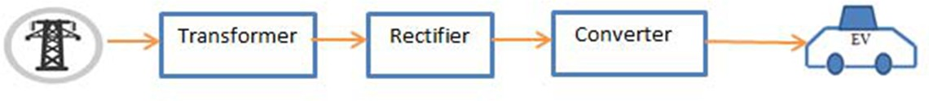

**Fig. 2.4:** Grid Connected Hybrid Renewable Energy-Based EVCS [20]

**CHAPTER 3**

**METHODOLOGY**

# Introduction

This chapter opens with a discussion of the suggested approach for assessing the design of a hybrid powered charging station system. A technique for determining the design of a Renewable-based hybrid charging station has been devised. Various relevant data have been gathered from the meteorological agency and other credible sources. An appropriate method was constructed by gathering and analyzing the input parameters. This chapter then focuses on the viability of RES-based charging stations to meet the power demand of a specific region. The methodological approach is demonstrated on **Fig. 3.1** with a flowchart.

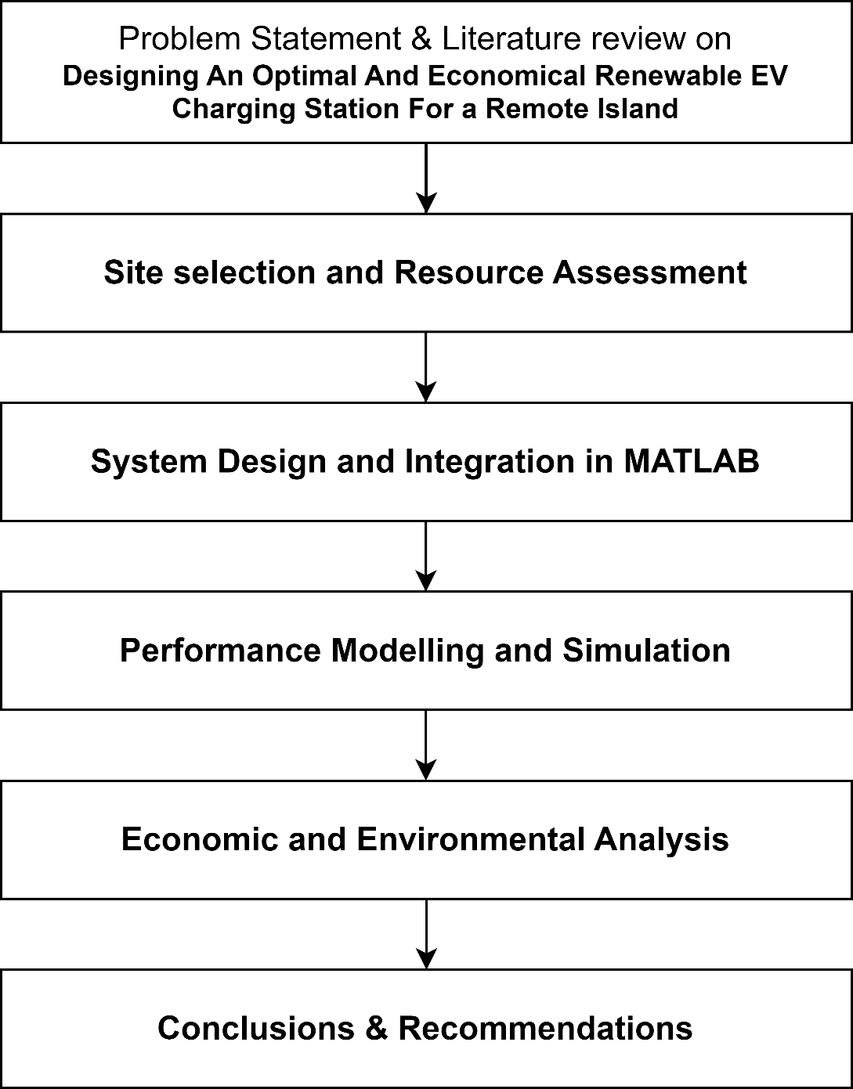

**Fig 3.1:** Flowchart for proposed methodology

# Literature Review

Conduct a thorough examination of current literature and research papers on hybrid renewable energy systems, EV charging infrastructure, and optimization approaches. Determine applicable technology, processes, and best practices used in comparable projects throughout the globe and the present state of renewable energy integration in Bangladesh, as well as the existing charging infrastructure and government legislation

# Site Selection and Resource Assessment:

Determine probable locations for grid-connected EV charging stations based on characteristics such as proximity to metropolitan areas, accessibility, solar irradiation, wind speed, and biomass resource availability. Using meteorological data we can do a complete on-site observation of solar irradiance, wind speed, and biomass availability at Mognama Ghat. Then Evaluate each renewable resource’s technical viability and prospective energy output.

### *System Design and Integration:*

Develop a hybrid renewable energy system design integrating solar panels, wind turbines, and biomass-based power generating technologies. To determine the best size and configuration for each component depending on the EV charging station’s energy consumption, resource availability, and system efficiency we have used Homer Software. Design the grid connection and electrical infrastructure to enable smooth integration with the current power system with MATLAB Simulink.

### *Performance Modelling and Simulation:*

Develop schematic models and simulation tools to evaluate the hybrid system’s performance under various operating situations and scenarios. Using Homer software, simulate the energy generation, storage, and distribution processes to analyze the system’s reliability, efficiency, and cost effectiveness. Optimize system characteristics such as renewable energy source capacity, energy storage systems, and charging infrastructure to maximize renewable energy consumption while minimizing costs.

* + 1. ***Economic and Environmental Analysis:***

Conduct a thorough economic analysis to deter- mine the financial viability of the planned charging station, taking into account initial investment, ongoing costs, and prospective revenue streams. Analyze the hybrid system’s environmental im- pact by looking at carbon emissions reduction, air quality improvement, and total ecological foot- print. Assess the economic and environmental performance of the proposed hybrid system in comparison to standard fossil fuel-based charging stations.

### *Conclusion and Recommendations:*

Summarize the study’s findings and highlight the benefits and drawbacks of the suggested hybrid-renewable charging station. Make suggestions for future upgrades and research directions. In order to achieve Bangladesh’s long-term development goals, it is critical to integrate renewable energy into the transportation sector.

### *Selection of Renewable Hybrid Charging Station :*

In broad terms, the placement of charging stations for electric vehicles requires an accurate assessment and forecast of charging demand, as well as an in-depth vehicle-road-network-source establishing organizes the priorities and necessities from various parties, such as electrical grid companies, charging equipment administrators, consumers, and power systems. The main difficulty is striking a balance between essential facilities and providing charging demand while decreasing the cost of establishing and operating EVCSs as much as possible while satisfying a specific charging demand for a given site, as illustrated in **Fig. 3.2**. Yet, the unpredictable nature of electric vehicle (EV) charging demand, as well as the irregularity of energy from renewable sources availability, is a substantial impediment to a small-scale energy management. For starters, uncontrollable elements like time and ownership of electric vehicles impact charging demand. In addition, the generated power of the micro-grid's WP, PV, and other sources of energy is visibly intermittent and inconsistent. The inconsistency in output power might easily fail to match charging demand, jeopardizing the power grid's steady operation. The energy storage device has the potential to lessen the variability of renewable energy sources as well as the pressure on the distribution network caused by load shedding. As a result, charging station facility design must account for the uncertainties of EV charging demand and renewable energy production in order to calculate an appropriate ratio of wind and solar capacity, as well as the capacity of energy storage equipment. Using previous data, this study computes the higher and lower limits of changes in power need and green energy generation using the kernel density function, and it evaluates the stability of the charging demand and green energy generation curve using the load fluctuations ratio. Robust evaluation is used to design the position and capacity of EVCSs, as well as compute the ability of wind and photovoltaic (PV) power plants and energy storage facilities (ESS). [21]

* Selected Location for the hybrid power plant should have proper solar exposure, sufficient wind energy to regulate wind turbine and proper biomass fuel.
* **Fig: 3.3** shows location selected at “Mognama ghat,Cox’s bazar” (21.823, 91.909) area.

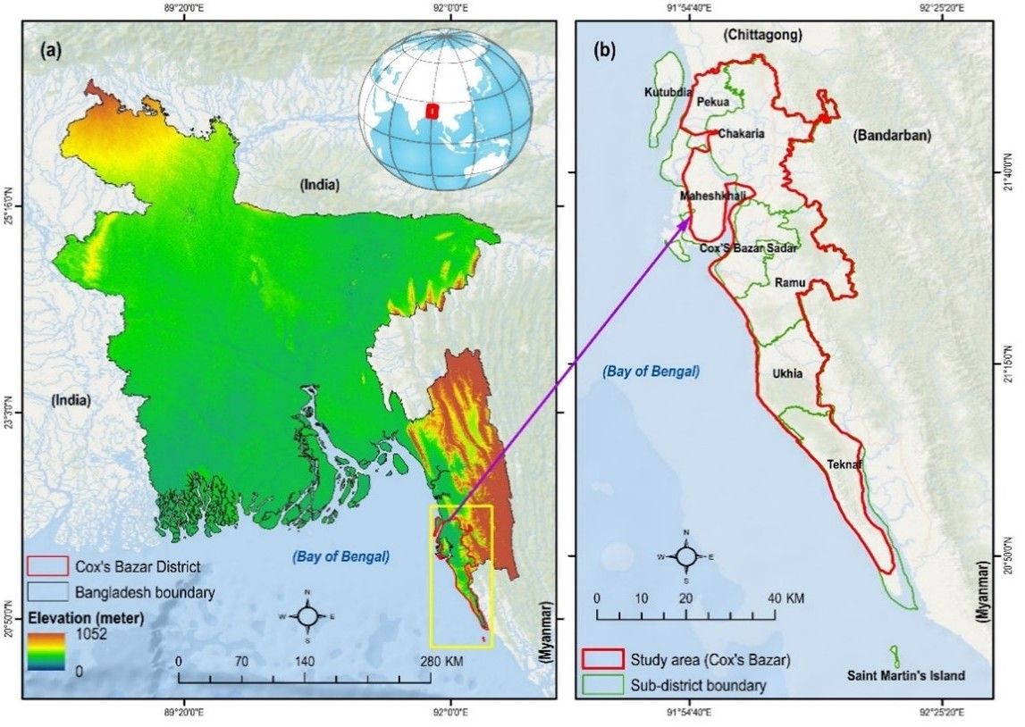

** Fig. 3.2**: Site Location of Hybrid Charging Station [22].

**Fig. 3.3**: Renewable Hybrid Charging Station Site: Mognama Ghat, Cox Bazar

* 1. **Renewable Resources For Charging Station**
     1. ***Solar Resource Analysis*:**

Solar radiation is an essential component of solar energy generation, but it is subject to seasonal variations in Bangladesh. The availability of solar energy fluctuates throughout the year due to factors such as cloud cover, atmospheric conditions, and the tilt of the Earth’s axis [23].

During the summer months, Bangladesh experiences higher solar radiation levels, resulting in increased solar energy generation. However, during the monsoon season, cloud cover and rainfall can reduce the amount of sunlight reaching the Earth’s surface, leading to decreased solar energy availability. Similarly, in winter, the shorter daylight hours and lower sun angle contribute to lower solar radiation levels.

In **Fig. 3.4** we see a 325Watt PV Panel. The power output from the PV module is obtained through Eq. (1), where PPV rated is the module’s rated capacity (325W), DF is the derating factor (80%), G (kW/m2 ) and GS (1 kW/m2) are the incident and the standard solar irradiations, respectively, and P (-0.55%/°C), TC (40°C), and TS (25°C) are the temperature coefficient of the power, PV cell temperature, and standard PV cell temperature, respectively .

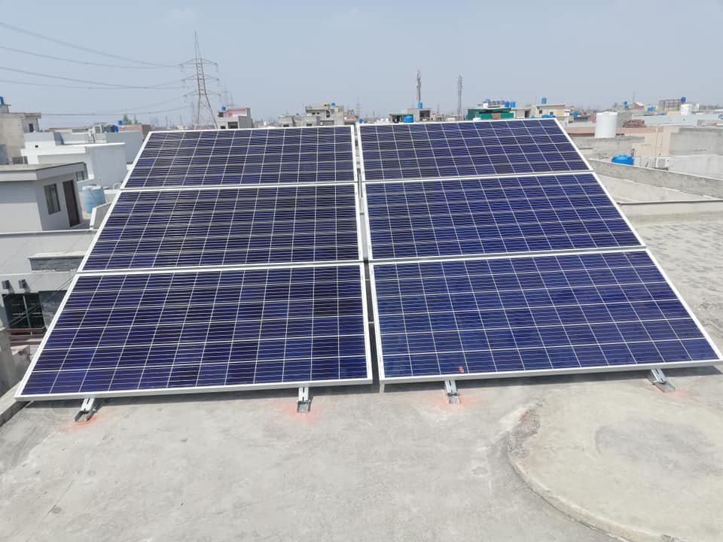PPV = PPV_rated DF ( ) [1 + αP(Tc – Ts)] ………………..**3.1**

**Fig. 3.4**: 325Watt PV Panel [24]

# *Solar radiation*

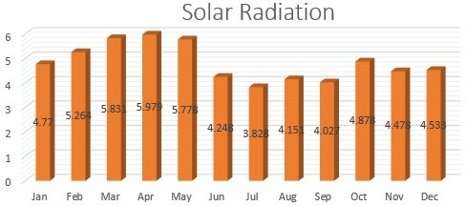

**Fig. 3.5:** Monthly Average Solar GHI

Solar irradiance (SI) is the power per unit area received from the sun in the form of electromagnetic radiation [25]. The solar global horizontal irradiance (GHI) throughout the year ranges from 3.81 kWh/m2/day to 6.09 kWh/m2/day, with an average of 4.77 kWh/m2/day.

**Fig. 3.5** Illustrates the monthly average solar radiation pattern, depicting the varying intensity of solar radiation received in different months.

# *Clearness index*

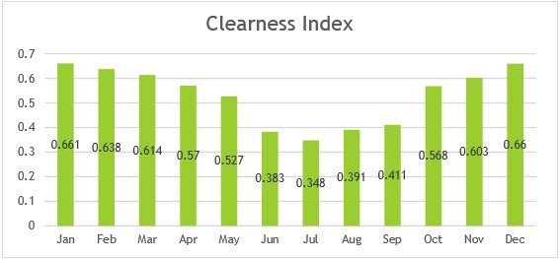The clearness index is a measure of the clearness of atmosphere [26]. From gathered we see clearness index varies from 0.347 to 0.664 throughout the year.

**Fig. 3.6:** Monthly Average Clearness index

For Bangladesh to have the most effective solar energy systems possible, designers must have a thorough understanding of the monthly average sun radiation pattern. This data is essential for choosing the best size for solar panels, energy storage devices, and backup options, guaranteeing a dependable and steady supply of electricity all year long. The Monthly Average Clearness Index of Solar is shown in the given **Fig. 3.6** along with the clearness index values for each month from January to December. The designers and operators of solar energy systems can learn a lot about the quantity of sunlight that is available throughout the year by evaluating this data shown in **Table. 3.1**, which will help them make wise decisions and put successful plans into action to harness solar energy in Bangladesh.

**Table 3.1**: Clear Index and Solar Radiation Data by Month

|  |  |  |
| --- | --- | --- |
| Month | Clear Index | Solar Radiation |
| Jan | 0.661 | 4.770 |
| Feb | 0.638 | 5.264 |
| Mar | 0.614 | 5.831 |
| Apr | 0.570 | 5.979 |
| May | 0.527 | 5.778 |
| Jun | 0.383 | 4.248 |
| Jul | 0.348 | 3.828 |
| Aug | 0.391 | 4.151 |
| Sep | 0.411 | 4.027 |
| Oct | 0.568 | 4.878 |
| Nov | 0.603 | 4.478 |
| Dec | 0.660 | 4.533 |

By considering the seasonal variations in solar radiation and implementing appropriate design and optimization strategies, such as tilting solar panels for maximum sun exposure and incorporating energy storage technologies, the intermittent nature of solar energy can be mitigated. This allows for a more efficient utilization of solar resources and helps to ensure a reliable and consistent supply of renewable energy in Bangladesh, despite the seasonal variations in solar radiation.

# *Wind Resource Analysis*

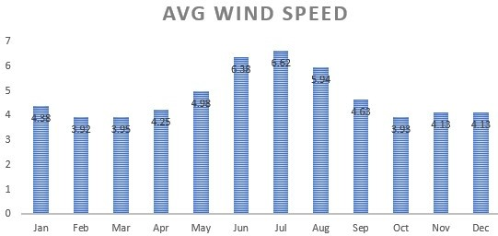Wind energy is a promising renewable resource that can be effectively harnessed in island and coastal areas of Bangladesh. These regions often experience favorable wind conditions, making them suitable for the installation of windmills or wind turbines to generate electricity. The monthly average wind speed ranges from 3.92 (m/s) to 6.62 (m/s) with an average of 4.77(m/s).

**Fig. 3.7:** Monthly Average Wind speed with Altitude and Anemometer Height

The average wind turbine's efficiency in transforming wind power to electricity is approximately 45% [27]. Wind energy has been identified in studies to be an important auxiliary resource for solar energy in generating power for this charge station. Locations, although experimentally observed wind speed statistics are not accessible [28]. Wind energy potential is modest in our suggested site. Wind Speed (km/h) statistics for several months in Mognama Ghat, Cox Bazar are provided in **Fig. 3.7**. Renewable energy from the wind is used to generate power by turning the kinetic energy of moving air into electricity. Wind energy has several advantages in these coastal and island settings. The monthly average wind speed at 40m hub height is shown in **Table. 3.2.** It provides a clean and sustainable source of electricity, reducing dependence on fossil fuels and lowering greenhouse gas emissions. Wind energy projects can contribute to the overall energy mix of the country, diversifying the sources of power generation and enhancing energy security. Theoretical extracted (max.) power from wind is:

*P* = *Cp* ∗ 1*/*2 ∗ *ρ* ∗ *A* ∗ *V* 3 ………………….**3.2**

Where, P = Potential power, Cp = Power coefficient,

*ρ* = Air density, V= Wind speed, A = Swept area of rotor ,

**Table 3.2:** Average Wind Speed by Month.

|  |  |
| --- | --- |
| Month | Avg Wind Speed |
| Jan | 4.38 |
| Feb | 3.92 |
| Mar | 3.95 |
| Apr | 4.25 |
| May | 4.98 |
| Jun | 6.38 |
| Jul | 6.62 |
| Aug | 5.94 |
| Sep | 4.63 |
| Oct | 3.93 |
| Nov | 4.13 |
| Dec | 4.13 |

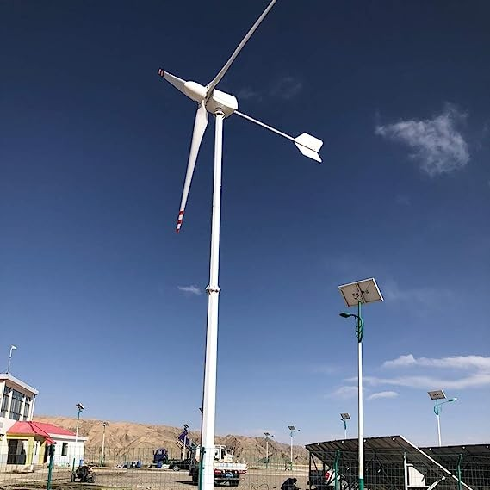

**Fig. 3.8:** 10kw Horizontal axis Wind Turbine [29]

**Fig. 3.8** shows a wind turbine that has produced 10 kW of power. The wind turbine is made up of a tower that holds a sizable rotor with numerous blades. The wind’s kinetic energy is captured by the rotating blades and transformed into mechanical energy. The turbine’s internal generator takes this mechanical energy and transforms it into electrical energy. This wind turbine showcases its capacity to harness the power of the wind and contribute to the generation of sustainable energy with an outstanding power output of 10 kW.

# *Biomass (MSW) Resource Analysis*

Bangladesh, as an agricultural country, has an abundance of biomass resources that may be used to generate electricity. According to the SREDA database, the Bangladesh Infrastructure Development Corporation Limited (IDCOL) has erected 71,934 biogas plants [30], and the electricity generated from the biogas might be used to charge EVs. These biomass resources include cattle dung, agricultural residues and waste, poultry droppings, water hyacinth, rice husk, and more.

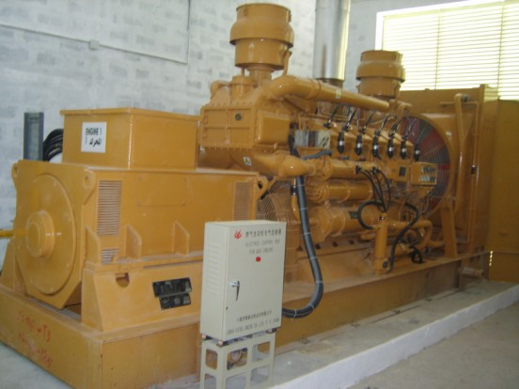Cattle dung, a byproduct of the livestock industry, can be processed and used as biomass fuel in power plants. Agricultural residues such as crop stalks, husks, and straw, which are typically left unused after harvesting, can also be converted into biomass fuel for energy generation. **Fig. 3.9** shows such biogas generator that utilizes poultry droppings, another organic waste product, can be harnessed as a valuable biomass resource. Water hyacinth, a fast-growing aquatic plant found in abundance in Bangladesh’s water bodies, can be collected and utilized as biomass feed stock. Similarly, rice husk, a byproduct of rice milling, can be used as a biomass fuel for electricity production.

**Fig. 3.9:** Biomass [31]

# *Monthly Average Available Biomass*

In Cox’s Bazar City Corporation, several types of waste are collected. The bulk of them are food wastes around 70% of total waste shown in **Fig. 3.10**. We know that food waste is ideal for biomass feed. According to Satyajit Roy Das et al., in terms of case study data, we assume 70% of waste feed, which is 60 tons per day in WTE technology from generated 90 tons per day. 50 to 90 tons per day, with an annual average of 63 tons per day. The monthly average available is illustrated at **Fig. 3.11.**

Gasification has the potential to assist the world in waste management while simultaneously creating the energy and goods necessary to promote economic development. With this method, one ton of MSW may create up to 1,000 kilowatt-hours of power, making it a far more efficient and ecologically benign way to use this source of energy [32]. So that, from 63 (t/d) waste we are expecting to get (63*1000) = 63000 KWh of electricity. From **Table:3.3** we can assume the availability of biomass throughout the year.

The availability of these diverse biomass resources in large quantities presents a significant opportunity for biomass power generation in Bangladesh. By utilizing these resources, the country

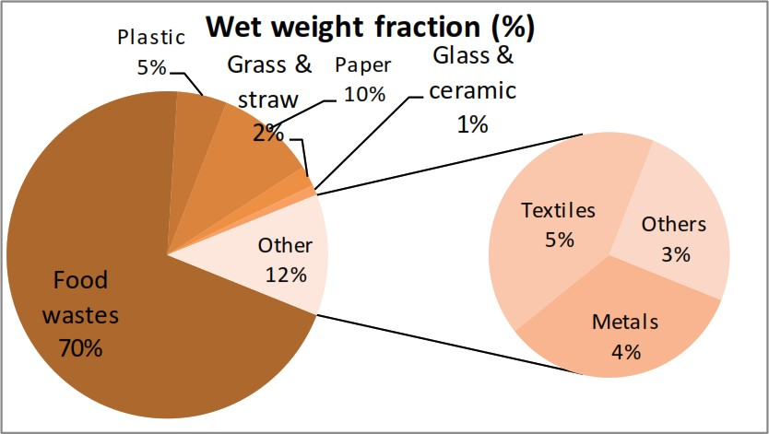

**Fig. 3.10**: Wet weight fraction (%) of municipal solid waste.

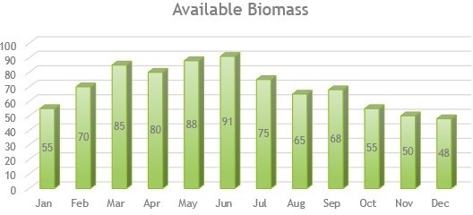

**Fig. 3.11**: Monthly Average Available Biomass*.*

can reduce dependence on fossil fuels, contribute to the renewable energy mix, and promote sustainable agricultural practices. Additionally, biomass power generation can help manage organic waste, improve waste management systems, and create employment opportunities in the biomass energy sector. Harnessing the potential of biomass resources aligns with Bangladesh’s goals of sustainable development and reducing greenhouse gas emissions. It enables the country to maximize the value of agricultural byproducts and organic waste, turning them into a valuable source of renewable energy for a greener and more self-sufficient energy future.

**Table 3.3:** Available Biomass by Month.

|  |  |
| --- | --- |
| Month | Available Biomass (tons) |
| January | 50.00 |
| February | 63.70 |
| March | 77.35 |
| April | 72.80 |
| May | 80.08 |
| June | 83.00 |
| July | 68.25 |
| August | 59.15 |
| September | 62.00 |
| October | 50.00 |
| November | 45.50 |
| December | 43.68 |

* 1. **Design of the Grid Hybrid Renewable Energy-Based Electric Vehicle Charging Station**
     1. ***General description:***

A renewable electric vehicle (EV) charging station that incorporates solar, wind, and biomass energy sources is designed to provide sustainable and clean power for charging electric vehicles. In accord with current scenarios, the combination of charging infrastructure to charge small EVs is explored. Here is a general description of such a charging station.

* + 1. ***Solar Panels:***

The charging station is equipped with an array of solar panels installed on its roof or in nearby areas with ample sunlight exposure. These panels convert sunlight into electricity through photovoltaic cells.

* + 1. ***Wind Turbines:***

Additionally, the charging station may have one or more wind turbines strategically placed in areas with consistent wind flow. The turbines transform the momentum of the breeze into electrical power.

* + 1. ***Biomass Generator:***

A biomass generator is integrated into the charging station to utilize organic materials such as agricultural waste, wood chips, or dedicated energy crops. These biomass sources are burned to produce heat, which in turn drives a turbine to generate electricity. Energy Storage: To ensure uninterrupted power supply, the charging station includes energy storage systems such as batteries. These structures retains extra power created throughout peak production cycles, which may then be used amid periods of low output or high demand.

* + 1. ***Energy Storage Systems:***

Batteries, such as lithium-ion batteries, are used to store surplus energy produced by solar panels, wind turbines, and biomass generators. These batteries store excess energy produced during times of high output and provide it when demand exceeds immediate renewable energy production. The stored energy may be used during times of low renewable energy supply or high charging demand.

* + 1. ***Power Converters:***

The charging station manages the various energy inputs from solar panels, wind turbines, and the biomass generator using power converters. These converters convert renewable energy's direct current (DC) energy into the alternating current (AC) energy needed to charge electric automobiles. They also guarantee that the charging infrastructure and the charging needs of the cars are compatible.

* + 1. ***Charging Infrastructure****:*

The charging station is equipped with multiple charging points or stations where electric vehicles can connect and charge their batteries. These charging points may include various charging standards (e.g., AC or DC fast charging) to cater to different vehicle models and charging needs. The integration of solar, wind, and biomass sources in the charging station promotes sustainability and reduces reliance on non-renewable energy sources. It allows electric vehicles to charge using clean energy, contributing to the reduction of greenhouse gas emissions and promoting the transition to a greener transportation system. **Fig. 3.12** illustrates such diagram of the HVCS.

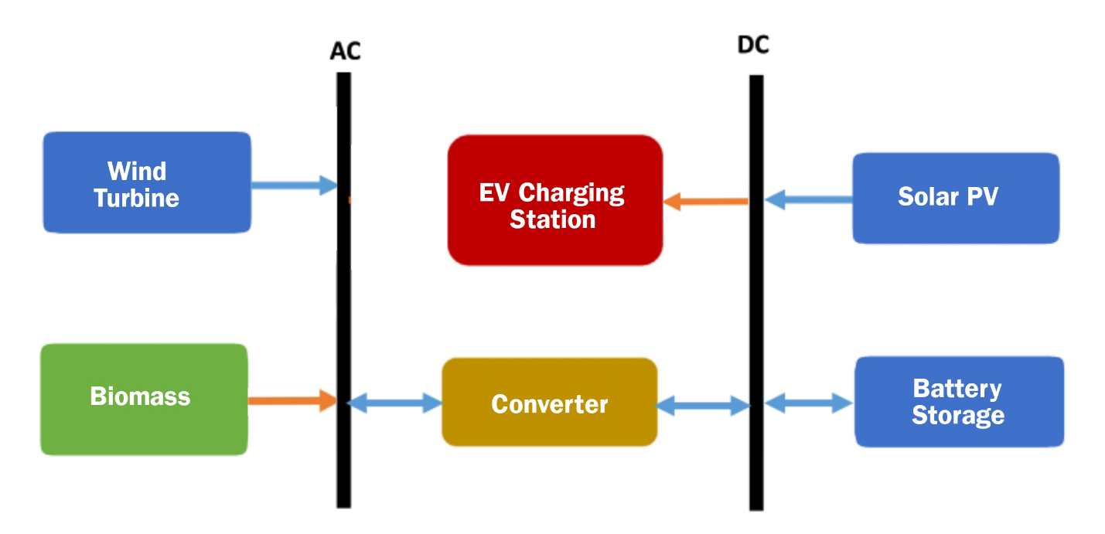

**Fig. 3.12:** Block diagram of the Hybrid Renewable Energy-Based EV Charging Station

* 1. **Electrical Vehicle Charging Station energy management**

The entire system's power flow is inconsistent because of the production of energy from renewable sources such as solar/wind/biomass. Figure 3.13 depicts the method used to manage power on the micro- grid. The electric-vehicle charging station is considered completely functioning

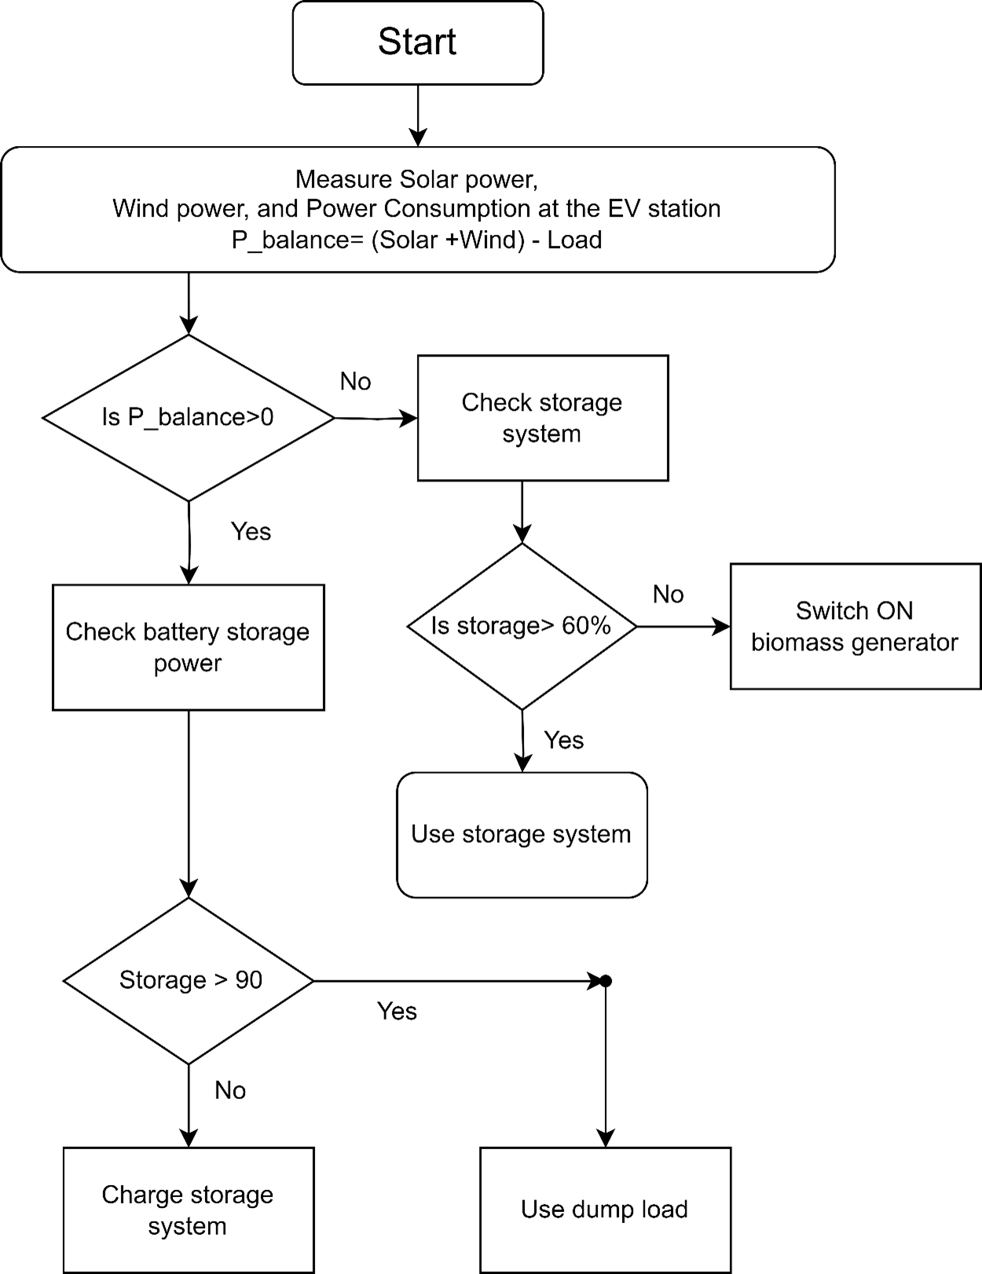

**Fig. 3.13**: Proposed algorithm for power management on the EV charging Station

In the proposed algorithm in **Fig. 3.13** the microgrid controller continuously monitors the energy generation from the renewable sources, the load side consumption, and the storage system's state of charge. The controller compares the energy generation from the wind and solar systems with the microgrid's total energy consumption, taking into account grid losses. It then makes decisions based on this comparison to manage energy flow. When the combined renewable energy generation exceeds the microgrid's demand and losses, surplus energy is used to charge the storage system and potentially charge electric vehicles at the EV station. The controller ensures that the storage system is not overcharged (above 80% capacity) to maintain optimal storage capacity for future excess energy. When the storage system falls below 60% capacity, indicating a need for recharging, the fuel generator is activated to supply additional energy. If renewable energy generation is insufficient to meet the microgrid's demand, the storage system steps in to supply electricity and prevent power disruptions. By effectively managing renewable energy, storage, and backup power, the microgrid reduces its reliance on the main grid, promoting sustainability and resilience. The system dynamically balances the energy supply and demand, ensuring a stable microgrid operation and preventing blackouts or system failures. Overall, this intelligent energy management system maximizes the utilization of renewable energy, minimizes reliance on conventional energy sources, optimizes storage capacity, and ensures a stable and reliable power supply for the microgrid, even during periods of low renewable energy generation or high demand. It's a sustainable and forward-looking approach to energy management, promoting cleaner energy usage and reducing carbon emissions.

### Electric vehicle Analysis

Currently, over 5,00,000 electric powered simple bikes or battery driven auto rickshaws run across the nation, using over 500MW of energy every day [33]. However, the rapid proliferation of EVs and charging stations has exacerbated voltage quality and harmonic distortion difficulties, compromising the operation of smart-grid electrical transmission networks. These vehicles are consuming 8.25 units of electricity on average per day and 250 units of electricity per month. Almost every electric car (such as easy bikes, auto rickshaws, and electric bikes) across Bangladesh are battery-powered. For a distance of 70-100 km, a battery-powered auto-rickshaw burns 8-11 kWh power each day [34]. Electric autorickshaws, also known as e-rickshaws or electric tuk-tuks, are powered by batteries that provide the required energy for their operation.EV Battery Specification of **Fig. 3.14** is specified in **Table. 3.4** below.

### Battery Type:



**Fig. 3.14**: 12v Lead Acid battery [35]

**Table-3.4**: Battery specification

|  |  |
| --- | --- |
| Specification | Value |
| Nominal Voltage | 12V |
| Self-discharging factor | 5% per month |
| SOC min | 30% |
| SOC max | 90% |
| Min charging rating | 10 hours |
| Charge/Discharge efficiency | 90% |
| Battery inverter cost | $606 |
| Lifetime of battery inverter | 10 years |
| Battery investment cost | $200 |

Lead-acid or lithium-ion batteries are commonly used in electric auto rickshaws. Lead-acid batteries are more prevalent because they are less expensive, although lithium-ion batteries have a better energy density and a longer lifespan [36].

### 

### Voltage:

The voltage of the battery pack can vary, but it is usually in the range of 48 volts to 72 volts [37]. Higher voltage systems generally provide more power and better performance.

### Capacity:

The battery capacity refers to the amount of energy the battery can store and is typically measured in ampere-hours (Ah). The capacity can range from around 100 Ah to 200 Ah or more, depending on the model [38]. Higher capacity batteries generally offer a longer driving range.

### Charging:

Electric auto rickshaw batteries can be charged using standard charging outlets. The charging time varies based on the battery capacity and charging rate. Fast charging options may be available in some models, allowing for quicker charging times.

### Range:

The driving range of an electric auto rickshaw depends on several factors, including battery capacity, vehicle efficiency, driving conditions, and payload. Generally, e-rickshaws can provide a range of around 80-100 kilometers on a single charge, but this can vary [39].

### ENERGY DEMAND OF EV (AUTO RICKSHAW):

In Bangladesh, EVs are being employed in the form of easy bikes and auto rickshaws. This study approximates the energy consumption of a simple bike used in Bangladesh.

Lead Acid Battery used in an Auto Rickshaw = 5 pcs

Rated voltage of each battery = 12 V

The current capacity of each battery = 140 Amp-hour

So, the energy stored in each battery

= {(140 × 12) ÷ 1000} kWh

= 1.68 kWh

Now, the total energy consumption of an auto rickshaw

= (5 × 1.68) kWh

= 8.4 kWh

Assume the charge controller's efficiency is about 90%.

So, charge controller loss = {(10 ÷ 100) × 8.4} kWh = 0.84 kWh

Therefore, overall energy consumption of an easy bike

= (8.4 + 0.84) kWh

= 9.24 kWh

The proposed charging station can able to charge maximum of 100 vehicles at a time in two shifts. So, the maximum demand of energy consumption is,

= 200 X 9.24KWh/6hour

= 1848KWh/day

Taking into account some additional demand, the Charging Station's capacity for steady operation is 2000 kWh.

# Characteristics of Renewable Charging Station Equipment

# *Photovoltaic Array System*

The energy generated by the PV system is DC, which is subsequently preserved in the energy storage system or converted to AC to power the load.

**Table 3.5**: Photovoltaic Array Characteristic.

|  |  |
| --- | --- |
| Characteristics | Quantity |
| Panel Type | Flat Plate |
| Rated Capacity (KW) | 325W |
| Temperature Coefficient | -0.42 |
| Nominal Operating Cell Temperature (°C) | 46.2°C |
| Efficiency (%) | 13% |
| Manufacturer | Generic |
| Ground Reflection (%) | 20% |
| De-rating Factor (%) | 85% |
| Panel slope (degrees) | 24.37° |

**Table. 3.5** provides a concise summary of various characteristics related to a specific solar panel. The panel type is described as a flat plate, indicating its physical design. The rated capacity of the panel is listed as 325W, representing the maximum power output it can generate under optimal conditions. The temperature coefficient is given as -0.42, indicating the panel’s response to changes in temperature. The nominal operating cell temperature is mentioned as 46.2°C, which represents the average temperature at which the panel operates. The efficiency of the panel is stated as 13%, indicating the percentage of sunlight it can convert into electricity. The manufacturer is listed as ”Generic.” Other important details include the ground reflection percentage (20%), de- rating factor (85%), and panel slope (24.37°). These specifications provide valuable information for understanding and evaluating the performance and characteristics of the solar panel.

# *Wind Turbine System*

The generated electricity in the wind turbine system is AC which is then converted to DC to store in the storage or supplied to the load .

**Table 3.6:** Wind Turbine Specifications

|  |  |
| --- | --- |
| Characteristics | Quantity |
| Type | Generic 10KW |
| Rated Capacity (KW) | 10KW |
| Manufacturer | Generic |
| Hub Height (m) | 40m |
| Lifetime (years) | 20 years |
| Startup Wind Speed (m/s) | 3 m/s |
| Rated Wind Speed (m/s) | 14 m/s |
| Cut Out Wind Speed (m/s) | 21 m/s |
| Power Regulation | Pitch Regulated with variable Speed |

**Table. 3.6** presented table outlines the specifications of a generic 10KW wind turbine. The type of the wind turbine is stated as ”Generic 10KW,” indicating its standard classification. The rated capacity of the turbine is listed as 10KW, denoting the maximum power output it can generate. The manufacturer is mentioned as ”Generic.” The hub height of the turbine is specified as 40m, representing the vertical distance from the base of the turbine to the center of the rotor hub. The expected lifetime of the turbine is noted as 20 years, signifying the anticipated operational duration. The startup wind speed is listed as 3 m/s, indicating the minimum wind speed required for the turbine to begin generating power. The standard wind speed is 14 m/s, which represents the maximum theoretical power production of the turbine at that speed. The velocity of the wind at which the wind turbine goes offline in order to avoid damage is specified as 21 m/s. The power regulation mechanism of the turbine is described as pitch regulated with vari able speed, suggesting that the turbine adjusts its blade pitch angle and rotor speed to optimize power generation. These specifications provide valuable information about the wind turbine’s capacity, operating parameters, and control mechanisms, aiding in its evaluation and application for renewable energy generation.

# *Biogas Generator*

Waste to Energy (WTE) technology can be used to transform non-recyclable garbage into useable energy sources such as heat, fuels, and electricity. Here it generates AC power. **Table. 3.7** presented table outlines the specifications of the Generic 100 KW Biogas Genset.

**Table 3.7:** Specifications of the Generic 100 KW Biogas Genset

|  |  |
| --- | --- |
| Characteristics | Quantity |
| Type | Generic 100 KW Biogas Genset |
| Capacity (KW) | 100 KW |
| Fuel | Biogas |
| Minimum Load Ratio (%) | 50% |
| Lifetime (hours) | 20,000 |
| Emissions (g/kg fuel) | CO – (2 g/kg fuel), NOx - (1.25 g/kg fuel) |
| Lower Heating Value (MJ/kg) | 5.5 MJ/kg |

# *System Converter*

Used to convert the DC generated electrical power to AC in order to supply to the local grid or to the converter the AC generated power to DC in order to store energy.

**Table 3.8:** Characteristics of the System Converter

|  |  |
| --- | --- |
| Characteristics | Quantity |
| Type | Generic System converter |
| Inverter Efficiency (%) | 95% |
| Inverter Lifetime (Years) | 15 years |
| Rectifier Efficiency (%) | 95% |
| Rectifier Lifetime (Years) | 15 years |
| AC Generated Connection | Parallel with AC generation |

**Table. 3.8** shows the properties and quantities of a generic system converter that is used to invert and rectify electrical power. The inverter has a 95% efficiency, which means it can convert a large proportion of direct current (DC) electricity to alternating current (AC). The inverter is predicted to last 15 years, demonstrating its robustness and endurance in operation. Similarly, the rectifier has a 95% efficiency and a 15-year lifespan. A rectifier is a device that transforms AC (alternating current) to direct current (DC). The AC generated connection is set up in parallel with the AC generation connection, indicating that the converter is intended to be linked to an AC power source for power production. Overall, this table gives critical information about the system converter's efficiency, longevity, and connection type, showing its potential for converting and controlling electrical power in a number of applications.

# *Storage System*

A battery bank is used to store energy from the planned hybrid system. The electric car is charged by connecting it to the AC bus through a charger. A generic 1 kWh lead acid battery is utilized in this study.

**Table 3.9:** Characteristics of the Storage system.

|  |  |
| --- | --- |
| Characteristics | Quantity |
| Nominal Voltage (V) | 2V |
| Nominal Capacity (KWh) | 6.07 |
| Maximum Capacity (Ah) | 5.13 |
| Capacity Ratio | 0.611 |
| Rate Constant (1/hr) | 1.09 |
| Effective Series Resistance (ohms) | 0.000596 |
| Other Round-Trip Losses (%) | 15% |
| Initial State of Charge (%) | 100% |
| Minimum State of Charge (%) | 40% |
| String Size | 24 |

**Table. 3.9** shows the technical specifications of a lead acid battery. An EV's battery lifetime is influenced by a variety of elements such as high temperature, filthy surroundings, low driving, flaws and driving patterns. The battery's lifespan diminishes as the operating temperature rises [40].

# Simulink Component list

## *Rectifiers*



**Fig. 3.15:** Rectifier[41]

Here, we’ll talk about rectifiers, both regulated and unregulated. At **Fig. 3.15,** an AC signal is transformed into a DC signal using rectifiers. Either one phase or three phases are possible. Here, electricity is transferred from the AC side to the DC side. It is common for power electronics components to require a DC supply. Because they are being fed from the AC supply, this correction is being made. The rectifiers’ output should have the fewest ripples feasible. In most cases, they can be used with chargers, batteries, DC motor drivers, DC servo motor drivers, etc. Additionally, rectifiers are employed in uninterruptible power supplies, which use little power. Diodes are utilized in uncontrolled rectifiers, while thyristors are typically employed in regulated rectifiers. We will describe one example of each type of rectifier—uncontrolled and controlled—in our study.

## *PV Array*

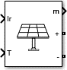

**Fig. 3.16**: PV Array [42]

A photovoltaic (PV) array is a system that harnesses sunlight and converts it into usable electricity through the use of solar panels. PV array shown in **Fig. 3.16** consists of multiple PV modules connected together to generate a significant amount of power. Each PV module contains individual solar cells made of semiconductor materials, typically silicon, which absorb sunlight and generate 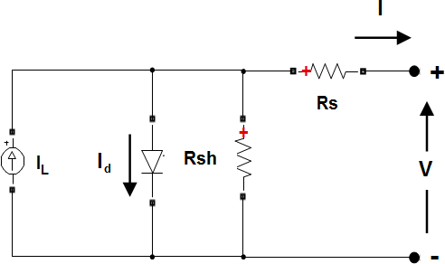an electric current.

**Fig. 3.17:** Circuit Diagram of PV [43]

The diode I-V characteristics for a single module are defined by the equations

*Id* = *I* [exp( *Vd* ) − 1]…………………**3.3**

0

*VT*

*VT* = *kTq* × *nI* × *N*cell………….…**3.4**

## *IGBT:*



**Fig. 3.18:** IGBT [44]

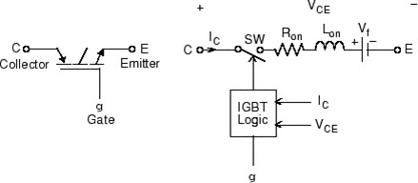The IGBT (Insulated Gate Bipolar Transistor) shown in **Fig. 3.18** is a semiconductor component that plays a crucial role in power electronics. It can be controlled by a gate signal to switch power between its ON and OFF states. When an appropriate control signal is applied to the gate, the IGBT acts as a low-resistance switch, allowing the flow of current through it. Conversely, when the gate signal is turned off, the IGBT behaves like a high-resistance switch, blocking the current flow.

**Fig. 3.19**: IGBT Circuit [45]

From **Fig. 3.19** we see, when the collector-emitter voltage is positive and larger than Vf, and a positive signal is provided to the gate input (g > 0), the IGBT switches on. When the collector-emitter voltage is positive and a 0 signal is sent to the gate input (g = 0), it shuts off.

When the collector-emitter voltage is negative, the IGBT device is in the off state. It should be noted that many commercial IGBTs lack reverse blocking functionality. As a result, they are often used in conjunction with an antiparallel diode.

* + 1. ***Repeating Sequence***



**Fig. 3.20**: Repeating Sequence [46]

The Repeating Sequence block illustrated at **Fig. 3.20** generates a periodic scalar signal with the waveform specified by the Time values and Output values parameters. A vector of output timings is specified by the Time values argument. The parameter Output values provides a vector of signal amplitudes at the relevant output timings. The two parameters indicate a sample of the output waveform at points measured from the start of the interval over which the waveform repeats (the signal's period). Both settings are set to [0 2] by default. These default parameters describe a saw-tooth waveform with a maximum amplitude of 2 that repeats every 2 seconds from the start of the simulation.

* + 1. ***Bus Selector***

The Bus Selector block outputs the components from the input bus that you choose. The chosen components may be output individually or in a new virtual bus by the block. As an output, the Bus Selector block does not permit combining message and signal components.

* + 1. ***Wind Turbine***

This example in **Fig. 3.21** explains how to model, parameterize, and test a turbine that produces electricity with overseeing, pitch angle, MPPT (maximum power point tracking), and scaling control. When you execute the plot function, it provides a plot of the state transitions, as well as normalized physical parameters such as wind speed, wind turbine rotation speed, generating power, and pitch angle.

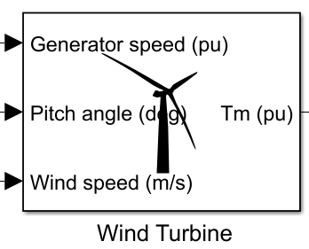

**Fig. 3.21:** Wind Turbine [47]

* + 1. ***Permanent Magnet Synchronous Machine***

The Permanent Magnet Synchronous Machine block is designed to simulate either a three-phase or a five-phase permanent magnet synchronous machine. In this model, the stator windings are connected in a wye configuration, which includes an internal neutral point. Depending on the configuration, the three-phase machine can exhibit a sinusoidal or trapezoidal back electromotive force (EMF) waveform. Additionally, the rotor of the machine can be either round or salient-pole for the sinusoidal machine, while it is always round for the trapezoidal machine. The block provides users with preset models for the sinusoidal back EMF machine, making it easier to use and integrate into simulations. For the five-phase machine, it generates a sinusoidal back EMF waveform with a round rotor. The block is versatile and allows users to tailor the simulation based on their specific needs and machine configurations. It is a valuable tool for studying and analyzing the performance of permanent magnet synchronous machines with different setups and characteristics.

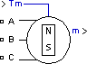

**Fig. 3.22:** Permanent Magnet [48]

A three-phase or five-phase permanent magnet synchronous machine is implemented using the Permanent Magnet Synchronous Machine block shown in **Fig: 3.22**. The stator windings are linked to an internal neutral point via a wye. The back EMF waveform of the three-phase machine might be sinusoidal or trapezoidal. For the sinusoidal machine, the rotor might be round or salient-pole. When the machine is trapezoidal, the rotor is circular. The sinusoidal back EMF machine has pre-programmed models. The five-phase machine features a circular rotor with a sinusoidal back EMF waveform. The Permanent Magnet Synchronous Machine block may work as a generator or a motor. The sign of the mechanical torque (positive for motor mode, negative for generator mode) determines the mode of operation. A second-order state-space model represents each of the machine's electrical and mechanical components. The sinusoidal model is based on the assumption that the flux created by the persistent.

* + 1. ***Three-Phase V-I Measurement***



**Fig. 3.23:** Three Phase V-I Measurement [49]

Here **Fig. 3.23** represents the Three-Phase V-I Measurement block is used in a circuit to measure instantaneous three-phase voltages and currents. It returns the three phase-to-ground or phase-to-phase peak voltages and currents when coupled in series with three-phase components. The voltages and currents may be output as per unit (pu) values or in volts and amperes. If you want to measure phase-to-ground voltages per unit, the block transforms the observed voltages depending on the nominal phase-to-ground voltage's peak value:

Vabc(pu)=Vphase to ground(V)/Vbase(V)………………………….**3.3**

where

Vbase=Vnom(Vrms)√3⋅√2 ……………………………………...**3.4**

If you choose to measure phase-to-phase voltages in per unit, the block converts the measured voltages based on peak value of nominal phase-to-phase voltage:

Vabc(pu)=Vphase to phase(V)**/**Vbase(V) …………………………..**3.5**

where

Vbase=Vnom(Vrms)⋅√2 …………………………………………**3.6**

If you choose to measure currents in per unit, the block converts the measured currents based on the peak value of the nominal current:

Iabc(pu)=Iabc(A)**/**Ibase(A) ………………………………………**3.7**

Where

Ibase=Pbase (Vnom∗√2**/**√3)………………………………………**3.8**

The Three-Phase V-I Measurement block dialog box is used to specify Vnom and Pbase. The steady-state voltage and current phasors measured by the Three-Phase V-I Measurement block may be retrieved by choosing Steady-State Voltages and Currents from the Powergui block. Even when the output signals are transformed to pu, the phasor magnitudes presented in Powergui remain in peak or RMS values.

* + 1. ***Three-Phase Parallel RLC Load***



**Fig- 3.24:** Three-Phase Parallel RLC Load [50]

The Three-Phase Parallel RLC Load block shown in **Fig. 3.24** is designed to represent a parallel arrangement of RLC components, providing a balanced three-phase load. This load maintains a constant impedance at the specified frequency. The active power and reactive power of the load are directly proportional to the square of the applied voltage. The block icon displays only the components with nonzero powers, simplifying the representation of the load's behavior and characteristics in the simulation.

* + 1. ***DC BATTERY***

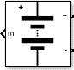

**Fig. 3.25**: DC BATTERY [51]

**Fig. 3.25** illustrates the most common kinds of rechargeable batteries using a general dynamic model. This diagram depicts the analogous circuit that the block represents.

* + 1. ***Charge and Discharge Characteristics***

When the battery is charged, the first part illustrates the exponential voltage decrease. The breadth of the drop is determined on the kind of battery. The charge that can be retrieved from the battery before the voltage falls below the battery's nominal voltage is shown in the second part in the above **Fig. 3.26**. Finally, the third portion shows the whole drain of the battery, which occurs when the voltage quickly declines. When the battery current is negative, it recharges according to a charge characteristic.

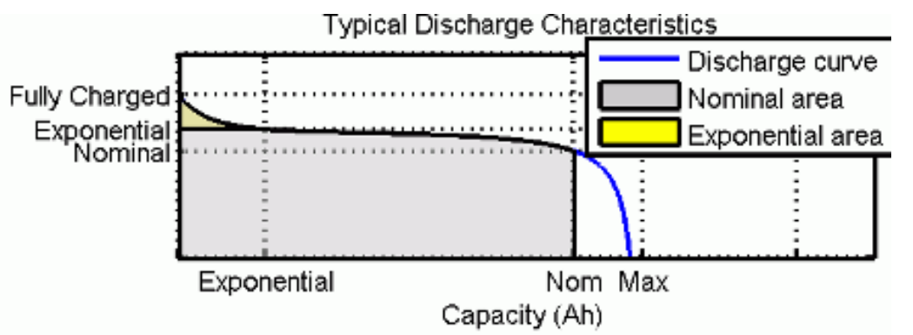

**Fig. 3.26:** Charge and Discharge Characteristics [52]

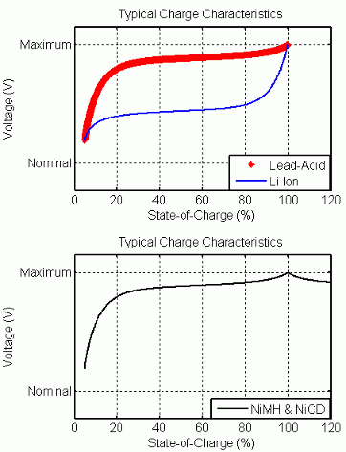The model parameters are derived from the discharge characteristics. The discharging and charging characteristics are assumed to be the same. The Exp(s) transfer function represents the hysteresis phenomenon for the lead-acid, nickel-cadmium (NiCD), and nickel-metal hydride shown in **Fig. 3.27**.

**Fig. 3.27:** Typical Charge Characteristics [53]

(NiMH) batteries during the charge and discharge cycles. The exponential voltage increases when a battery is charging, regardless of the battery’s state of charge illustrated in **Fig. 3.27**. When the battery is discharging, the exponential voltage decreases immediately like in **Fig. 3.28**.

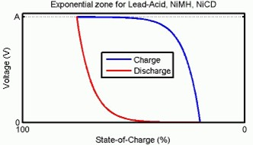

**Fig. 3.28:** Exponential Zone [54]

A battery's state of charge (SOC) is a measurement of its charge expressed as a percentage of its full charge. The depth of discharge (DOD) is the numerical counterpart of the SOC, with DOD equaling 100% - SOC.

For instance, if the SOC is:

• 100% - The battery is completely charged, and the DOD is zero.

• 75% - The battery is about 3/4 charged, while the DOD is around 25%.

• 50% - The battery is half-charged, and the DOD is half-charged.

• 0% - The battery is completely charged, and the DOD is 100%.

Model Validation: The model's experimental validation indicates a maximum inaccuracy of 5% (when SOC is between 10% and 100%) for the charge (when the current is 0 through 2 C) and discharge (when the current is 0 through 5 C) dynamics.

* + 1. ***DIODE***



**Fig. 3.29:** Diode [55]

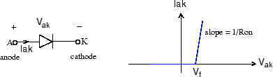In **Fig. 3.29**, the diode is a semiconductor device that is controlled by its own voltage *Vak* and current *Iak*. When a diode is forward biased (*Vak >* 0), it starts to conduct with a small forward voltage *Vf* across it. It turns off when the current flow into the device becomes 0. When the diode is reverse biased (*Vak <* 0), it stays in the off state. The Diode block is simulated by a resistor, an inductor

**Fig. 3.30:** Diode Circuit [56]

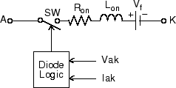and a DC voltage source connected in series with a switch. The switch operation is controlled by the voltage *Vak* and the current *Iak*. The Diode block in **Fig. 3.31** also contains a series *Rs*-*Cs* snubber circuit that can be connected in parallel with the diode device (between nodes A and K).

**Fig. 3.31:** Diode block [57]

**CHAPTER 4**

**PROCESS MODELING AND SIMULATION**

# Design of the Hybrid Renewable Energy-Based Electric Vehicle Charging Station

### *General Description*

A renewable electric vehicle (EV) charging station that incorporates solar, wind, and biomass energy sources is designed to provide sustainable and clean power for charging electric vehicles. Integration of charging stations to charge small EVs is discussed in accordance with existing scenarios. Here is a general description of such a charging station.

## *Solar Panels*



**Fig. 4.1:** Solar panel

The charging station is equipped with an array of solar panels installed on its roof or in nearby areas with ample sunlight exposure shown above in **Fig. 4.1**. These panels convert sunlight into electricity through photo- voltaic cells.

## *Wind Turbines:*



**Fig. 4.2**: Wind Turbine

Additionally, the charging station may have one or more wind turbines strategically placed in areas with consistent wind flow. Wind turbines harness the kinetic energy of the wind and convert it into electrical energy. **Fig. 4.2** represents the Simulink model of Wind Turbine.

## *Biogas Generator:*



**Fig. 4.3:** Biogas generator

**Fig. 4.3** shows the Simulink model of a biogas generator that is integrated into the charging station to utilize organic materials such as agricultural waste, wood chips, or dedicated energy crops. These biomass sources are burned to produce heat, which in turn drives a turbine

generate electricity.

# Output of the Hybrid Renewable Energy-Based Electric Vehicle Charging Station

## *Output of PV-MATLAB model*

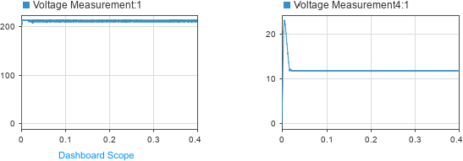

**Fig. 4.4**: Output curve of PV solar panel

In above **Fig. 4.4**, The stabilization at 12 indicates that the PV system's output reaches a steady-state value after experiencing transient behavior. This behavior is due to the system's response to the changes in the input parameters.

## *Output of the Wind energy-MATLAB model*

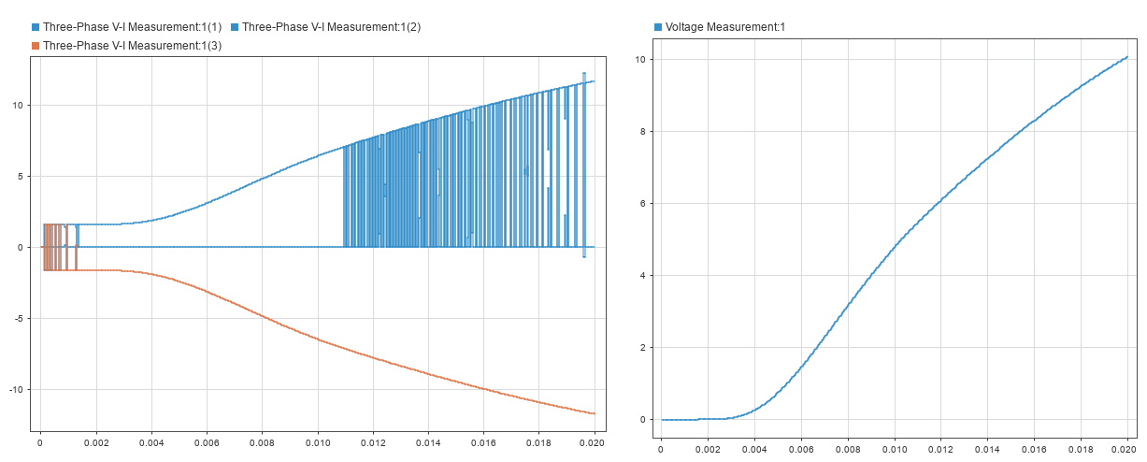

**Fig. 4.5:** Output curve of Wind turbine

**Fig. 4.5**, represents that wind system's output reaches a steady-state value after experiencing transient behavior. This behavior is due to the system's response to the changes in the input parameters.

## *Output of the Biomass MATLAB model*

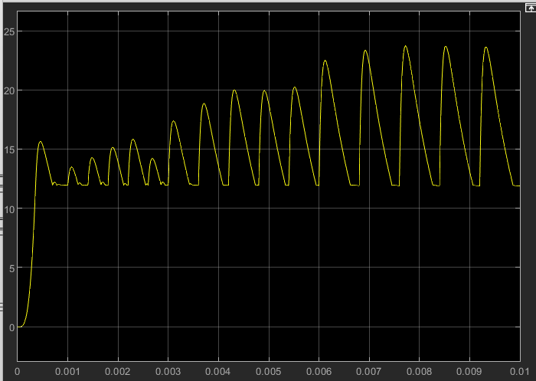

**Fig. 4.6:** Output curve of Biomass

**Fig. 4.6**, represents that biogas generator output. At some point, the power curve may start to level off or saturate. This saturation point occurs when the generator reaches its maximum capacity, and further increasing the biomass input does not lead to a significant increase in power output. At this point, the generator is operating at its peak performance, and additional fuel input may not result in proportionally higher power output.

**CHAPTER 5**

**RESULT AND DISCUSSION**

# Introduction

In this chapter the results will be presented for final proposed renewable energy production Homer energy simulation in solar, wind and biomass power. We have considered hybrid model with different parameter with respect to our electric vehicle charging load. HOWER does simulations and optimizations based on requirements to determine the optimum planned combination that provides the greatest performance in terms of cost and technical elements. Here we have discussed about Electrical production of system, Capacity shortage cost summery, cash flow of system, Cost of energy (COE) and finally CO2 emission.

# Hybrid Power generation in MATLAB simulation

**Fig. 5.1** showcases an integrated renewable energy system featuring a photovoltaic (PV) array, a wind turbine, and a biomass generator. While the PV array generates direct current (DC) voltage, the biomass generator and wind turbine produce alternating current (AC) voltage. To harmonize the generated power, an AC to DC converter is employed, converting the AC voltage from the biomass generator and wind turbine into DC voltage. This allows for compatibility and uniformity within the system. To maintain stable voltage levels, a Proportional-Integral-Derivative (PID) controller regulates the saturation voltage, optimizing system performance. Together, this integrated system



**Fig. 5.1**: Hybrid Power generation in MATLAB simulation

enables efficient utilization of renewable energy sources, ensuring a sustainable and reliable power supply while maintaining compatibility, stability, and control.

# Output result of Hybrid Power generation in MATLAB simulation

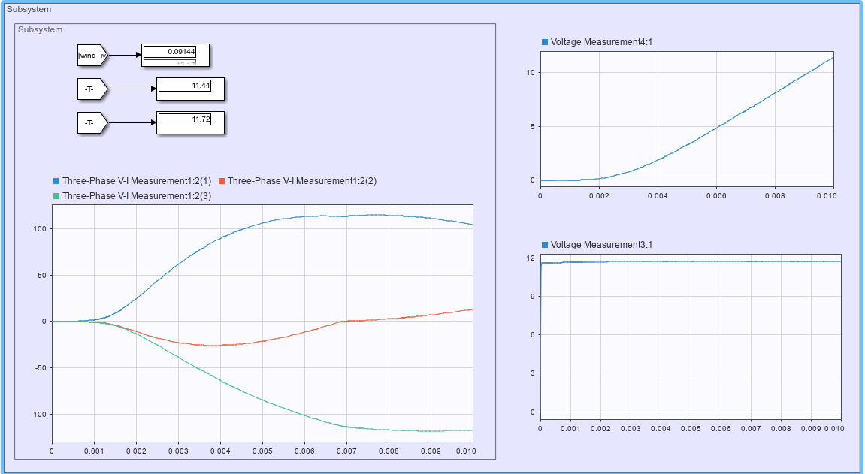

**Fig. 5.2**: Output Wave of Wind

**Fig. 5.2** represents the output wave of the wind turbine. It demonstrates the variation in generated electrical Voltage over time. The graph depicts the alternating nature of the wind voltage output, showing cycles of positive and negative values.

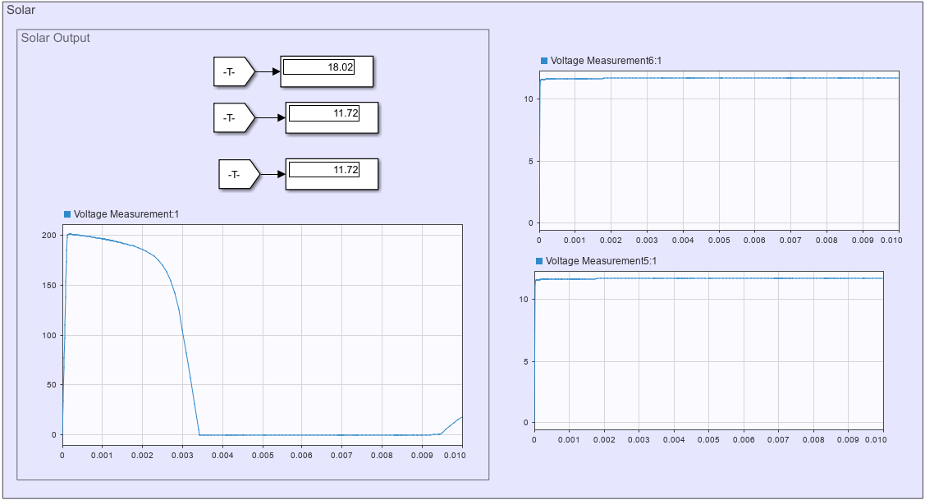

**Fig. 5.3**: Output Wave of Solar

In **Fig. 5.3**, the output wave of the solar PV array is illustrated. It showcases the fluctuation of the generated energy over time, following the availability of sunlight. The graph displays a relatively consistent wave with positive values, indicating a continuous and predictable solar energy generation pattern.

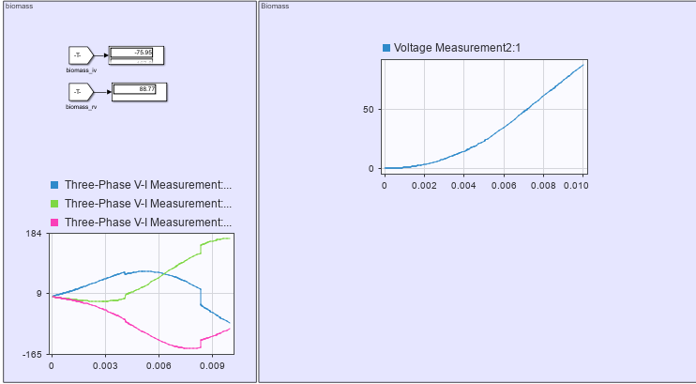

**Fig. 5.4**: Output Wave of Biomass

**Fig. 5.4** portrays the output wave of the biomass generator. The graph demonstrates the generation of electrical energy from biomass sources over time. The wave pattern may vary depending on the biomass feedstock and the operational characteristics of the generator. The amplitude and frequency of the wave highlight the energy output variations associated with the availability and combustion of biomass materials.

# Monthly Electric Production

**Fig. 5.5** shows the contribution of PV, Wind, and Biomass in the monthly average electricity production. The PV system reflects a contribution of 7.70% (53,073 kWh/year) towards electricity

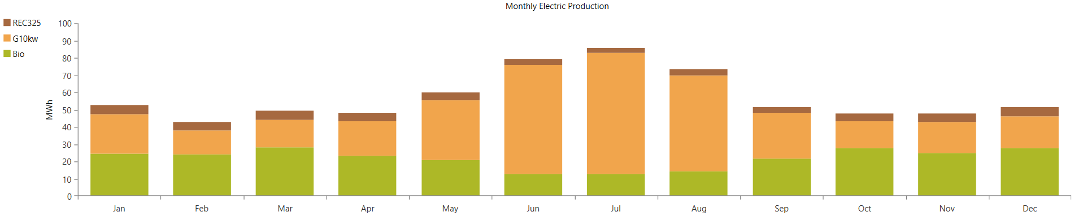

**Fig. 5.5:** Monthly Production

generation. The Wind energy system generates electricity at a rate of 54.3% (373,138 kWh/year), and the Biomass system contributes 38% (262,250 kWh/year) towards electricity generation shown in **Table: 5.1**.

**Table 5.1:** Total Electricity Production by Renewable Sources

|  |  |  |
| --- | --- | --- |
| **Production** | **KWh/year** | **Percentage** |
| PV Cell | 53,073 | 7.69% |
| Wind | 374,178 | 54.26% |
| Biomass | 262,250 | 38.03% |
| Total | 689,501 | 100% |

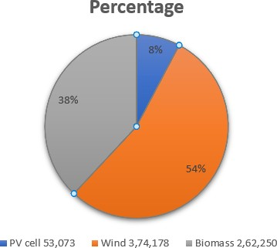

**Fig. 5.6**: Production of pi chart

**Fig. 5.6** shows the annual contribution of electricity production by PV, wind, and Biomass.

Total power = *P*PV cell + *P*Wind + *P*Biomass

= (53,073 + 374,178 + 262,250) kWh/year

= 689,743 kWh/year

= 1889.70 kWh/day

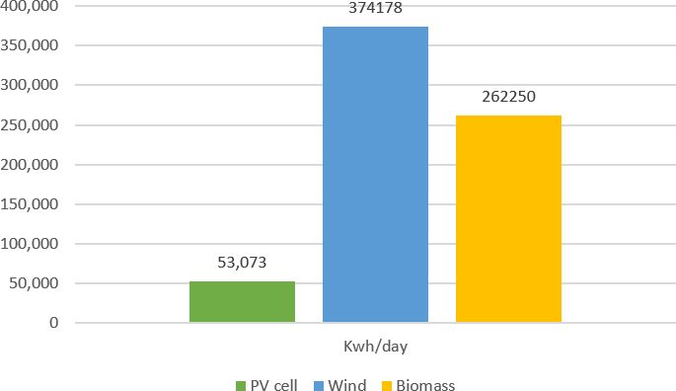

**Fig. 5.7:**  Nominal power generation capacity of wind/solar/biomass energy resources

**Fig. 5.7** shows that PV or solar generated 53,073 kWh/day and Wind generated 374,178 kWh/day and Biomass generated 262250 kWh/day and the Maximum power generated by the Wind.

# Cost Summary

**Fig. 5.8** depicts the Net Present Cost (NPC), which indicates the system's life cycle. The sum of the NPC summarizes all expenditures and profits that occur over the project's lifespan. Capital expenses, replacement costs, expenses for upkeep and operation, fuel, and so on are all examples of costs.

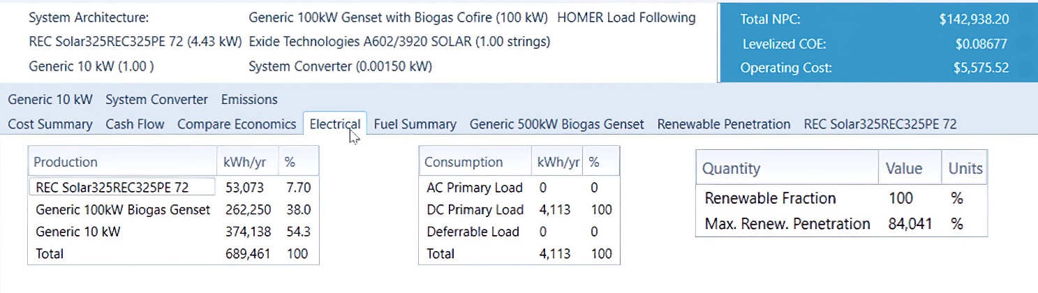

**Fig. 5.8:** Net Present Cost (NPC)

And miscellaneous costs such as penalties resulting from pollutant emissions. Costs for Generators mainly reflect the capital cost. Other costs chiefly indicate the operating cost It is clear from the above figure that, in our designed system most costs go installation cost.

**Table 5.2**: Component Costs.

|  |  |  |  |  |  |
| --- | --- | --- | --- | --- | --- |
| Components | Capital ($) | Replacement ($) | O&M ($) | Salvage ($) | Total ($) |
| Generic 10kW | 13,500.00 | 4,303.90 | 1,745.21 | -2,425.52 | 17,123.59 |
| Generic 100kW biogas genset | 57,000.00 | 672.59 | 67,804.82 | -329.99 | 125,147.42 |
| REC Solar | 145.80 | 0.00 | 232.70 | 0.00 | 378.50 |
| System converter | 214.76 | 91.12 | 0.00 | -17.15 | 288.73 |
| System | 70,860.56 | 5,067.61 | 69,782.73 | -2,772.66 | 142,938.24 |

**Table. 5.2** shows the total cost summery of renewable energy system. Here includes the capital, replacement cost, Operation & Management cost , Salvage.

# Cash Flow

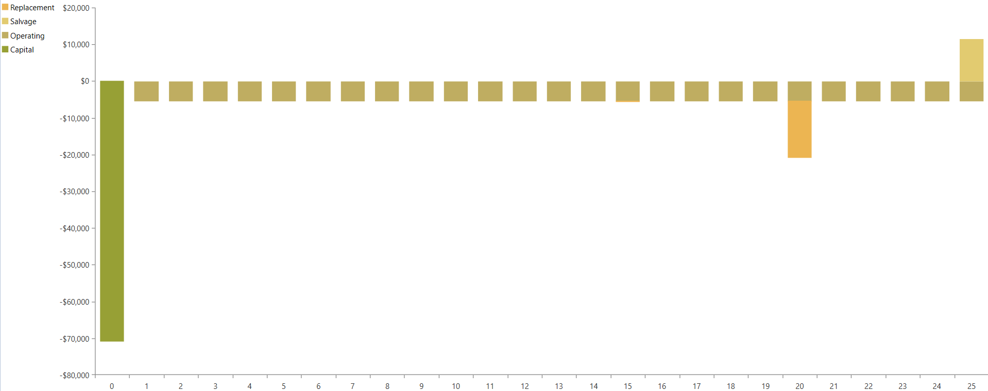

**Fig. 5.9**: Cash Flow

The **Fig. 5.9** shows the cash flow in a turbine power system as. It is clear from the figure that, at the starting year we need the capital cost which is very high . And in the next following years only the operating costs are required. Usually wind power plants have a 25 year lifetime.

# Cost energy of the system

Total NPC - $142,938.20

Operating Cost - $5,575.52 Per unit Cost ($) - $0.082

# Payback

The payback time is given by the equation:

Payback Time = Capital Cost of Project = 6*.*5 years

Annual Cash Out

Payback duration and lifetime is given below here in **Table. 5.3**.

**Table 5.3**: Table for Payback Year

|  |  |  |
| --- | --- | --- |
| Production | Payback In Years | Lifetime Years |
| PV | 8 | 25 |
| Wind | 5 | 25 |
| Biomass | 7 | 15 |

# Modeling of the Environmental Parameters

The total GHG emissions released by a power plant are used to determine environmental feasibility. These gases include CO2, SO2, NO, and other pollutants that contribute to environmental pollution, jeopardizing human life and harming animals. CO2 emissions from hybrid renewable energy-based EVCS are estimated in this article. The relevant factors for this feasibility test are the emission factor and total CO2 emissions from the charging station.

### Emission Factor:

It indicates a figure that aims to link the number of pollutants (i.e., GHG gases) discharged into the environment per unit of electricity production. It is usually expressed in kg/kWh: Emission,

E = *P* · *Ef* · *F* · (1 − *ηr*)……………………………………………………………**5.1**

where P is the entire generating capacity, EF is the emission factor, and R is the system’s overall pollution reduction efficiency

Σi(GWPi × (EFi + Eci + Eoi + EDi + EB&C)/PT )………………**5.2**

where i represents the kind of GHG and GWP is the global warming potential factor for each GHG EF denotes direct emissions from the burning of fossil fuels. EC = emissions associated with plant construction; EO = emissions associated with plant operation and maintenance; ED

= emissions associated with plant decommissioning; EBC = emissions associated with battery storage and charging device; PNet = net power production during the lifespan of the system

Total CO2 emission in a renewable energy based power plant can be calculated using This Equation :

Σ*i*(*CO*2*i* × *Capi* + Σ*d* Σ*d CO*2 × *Ethermal,d,t* + *CO*2*batt* × *Capbatt* + *CO*2*charge*) …………………………………………………………**5.3**

In this equation, CO2 denotes direct emissions from fuel combustion, CO2 denotes annualized indirect emissions from the system, Capi denotes plant capacity, Thermal denotes energy produced at time t of day d, CO2 Batt denotes CO2 emissions produced by the battery, Cap Batt denotes battery capacity, and CO2 Charger denotes CO2 generated by the charger itself. The CO2 produced per kWh of electricity in a hybrid renewable energy-based EVCS should be less than that produced by a typical power producing system. If the environmental feasibility test yields a negative result, the proposed model will fail or be rejected. Another worry is that the extracts generated by the biogas system are used appropriately. They might be solid ash or fly ash. The right use of these extracts may aid in the reduction of pollution produced by waste generated by the hybrid system.

# Environmental Impact

The factor of CO2 emission rate for Bangladesh is found 540 g/kWh [58]. Following that, we examine the percentage share of energy producing capacity and relative carbon emission output for each year of the trajectory.

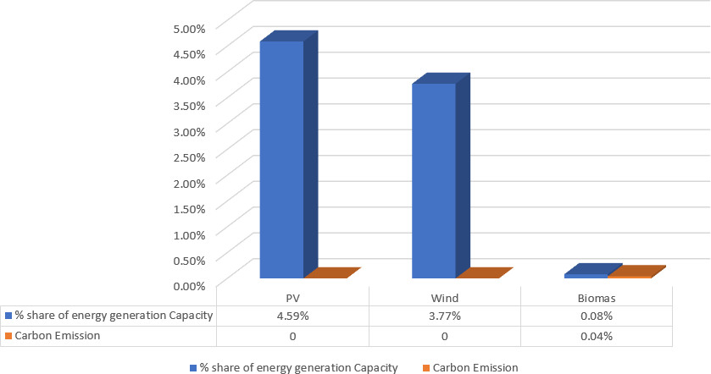

**Fig. 5.10**: Environment emission

**Fig. 5.10** shows the CO2 emissions with the different contributions of renewable energy, and it can be seen that the emissions drop as the size of the plant grows. Our results reveal that a 2MW power plant emits -2433962 kg/yr CO2 each year. Because this system has a surplus of energy, it sells more power than it acquires from the grid, resulting in negative CO2 emissions in all circumstances.

# Carbon emission:

This conclusion is supported by the present study’s findings. As a result, energy policy must focus on how to minimize carbon emissions in a mixed energy system while employing diverse approaches to meet energy demand.

This part discusses the adverse environmental impacts of these three hybrid renewable energy generating plants. The CO2 emissions of all models have a negative number since each hybrid model sells more energy to the grid than it purchases from the grid each year. Magnama ghat has the greatest value, -2873867 kg/yr for 2 MW. It is feasible to decrease a significant quantity of CO2 gas from the environment by constructing the suggested power plant.

As Bangladesh is rich in renewable resources and has an ideal position to collect energy sources such as solar, wind, and biomass, raising understanding and practices in Renewable Energy technology might be the cornerstone for carbon emission reduction in this Bangladesh. However, our findings suggest that in the near run, RE in its current form cannot offset the large production of carbon emissions from Fossil Fuel . As a result, further research into enhancing the energy generating capability of renewable resources is required for long-term prospects. It is also more probable that a variety of activities, as well as the enhancement of renewable and sustainable energy, will be required to decrease carbon emission in Bangladesh. Improved ecological and energy management approaches, carbon capture, and financial aspects such as carbon levies, as well as increased stakeholder commitment to increasing RE and lowering FF consumption, are some examples. To reduce carbon emissions in the long run, all of these measures must be in place and working in tandem with improved RE technology. A feasible approach that can be implemented is a scenario in which at least one of the FF sources is phased out of the energy sector For Electric vehicle Charging station and replaced with better RE technology installation.

**CHAPTER 6**

**CONCLUSION**

### Conclusion

In Bangladesh, the number of electric vehicles (EVs) is fast increasing. It’s a wonderful news for the future of EVs, but also increases grid demand and contributes to the power problem. Although these EVs seem to be environmentally beneficial, they contribute to pollution since they consume grid electricity. Because this grid electricity is produced from natural gas, oil, coal, and other fossil fuels. At this time, if the planned SCS can meet the present demand for EVs, it will gain favor. Then it will be simple to create a project system model and lower generating costs. When compared to wind/battery power systems and PV/battery systems, the optimization findings clearly illustrate that hybrid PV, Wind, Based hybrid power system gives the greatest performance and displays the most cost efficient design in terms of NPC and COE. It has maximum sources where peak load may be readily adjusted. It fully employs renewable systems and has a high renewable generation capacity. It significantly reduces CO2 emissions. Finally, employing renewable sources, it is conceivable to build a hybrid renewable charging station at Mognama ghat, Cox Bazar. When all feasibility aspects are considered, this Hybrid Renewable Power system might be the final answer to current power issue in Bangladesh.

### 6.2 Future work

1. The more efficient and updated cost analysis inputs of the components can be implemented in the simulation process.
2. Some general and default inputs of the simulation components may be modified and improved.
3. The hydrokinetic energy (Micro hydro turbine) of the nearest river can be added to the hybrid system to expand the power generation capacity.
4. Pumped Storage Hydropower (PSH) can be implemented to work as hydroelectric energy storage, which is more efficient than batteries.

**REFERENCES**

1. S. K. Agrawal, *Internal combustion engines*, 2nd Edition, India: New Age International, 2006, pp. 237-240.
2. M. Ali, S. Mohammad, and M. M. Rahman, "Modelling a solar charge station for electric vehicle with storage backup," in *2019 1st International Conference on Advances in Science, Engineering and Robotics Technology (ICASERT)*, IEEE, pp. 1-4, 2019.
3. R. Fachrizal, M. Shepero, D. van der Meer, J. Munkhammar, and J. Widén, "Smart charging of electric vehicles considering photovoltaic power production and electricity consumption: A review*," ETransportation*, vol. 4, p. 100056, 2020.
4. A. M. Hasan, "Electric rickshaw charging stations as distributed energy storages for integrating intermittent renewable energy sources: a case of Bangladesh," *Energies*, vol. 13, no. 22, p. 6119, 2020.
5. M. N. Rahman, A. M. Akash, M. A. B. Rony, and R. Islam, "An assessment of battery operated auto rickshaw’s impact: A case study in rangpur city bangladesh," *International Journal of Advance Study and Research Work,* vol. 2, no. 1, pp. 2581-5997, 2019.
6. M. R. Mozafar, M. H. Moradi, and M. H. Amini, "A simultaneous approach for optimal allocation of renewable energy sources and electric vehicle charging stations in smart grids based on improved GA-PSO algorithm," *Sustainable cities and society*, vol. 32, pp. 627-637, 2017.
7. The Connecticut Green Bank is the nation’s first green bank, date of access: 18/07/2023, retrieved from: <https://openquasi.ct.gov/checkbook/Connecticut%20Green%20Bank>.
8. A. K. Karmaker, M. R. Ahmed, M. A. Hossain, and M. M. Sikder, "Feasibility assessment & design of hybrid renewable energy based electric vehicle charging station in Bangladesh," *Sustainable cities and society*, vol. 39, pp. 189-202, 2018.
9. Albatayneh, Aiman, Mohammad N. Assaf, Dariusz Alterman, and Mustafa Jaradat. "Comparison of the overall energy efficiency for internal combustion engine vehicles and electric vehicles." *Rigas Tehniskas Universitates Zinatniskie Raksti 24*, pp. 669-680, 2020.
10. L. Reijnders and M. A. Huijbregts, "Life cycle greenhouse gas emissions, fossil fuel demand and solar energy conversion efficiency in European bioethanol production for automotive purposes," *Journal of Cleaner Production*, vol. 15, no. 18, pp. 1806-1812, 2007.
11. H. Chang et al., "Experimental study on comprehensive utilization of solar energy and energy balance in an integrated solar house," *Energy Conversion and Management*, vol. 105, pp. 967-976, 2015.
12. G. Ofualagba and E. Ubeku, "Wind energy conversion system-wind turbine modeling," in *2008 IEEE power and energy society general meeting-conversion and delivery of electrical energy in the 21st centur*y, IEEE, pp. 1-8, 2008.
13. A. E. Eneh and S. N. Oluigbo, "Mitigating the impact of climate change through waste recycling," *Research Journal of Environmental and Earth Sciences*, vol. 4, no. 8, pp. 776-781, 2012.
14. M. N. H. Suman, F. A. Chyon, and M. S. Ahmmed, "Business strategy in Bangladesh—Electric vehicle SWOT-AHP analysis: Case study," *International Journal of Engineering Business Management*, vol. 12, p. 1847979020941487, 2020.
15. A. K. Karmaker, M. R. Ahmed, M. A. Hossain, and M. M. Sikder, "Feasibility assessment & design of hybrid renewable energy based electric vehicle charging station in Bangladesh," *Sustainable cities and society*, vol. 39, pp. 189-202, 2018.
16. M. Amini, O. Karabasoglu, M. D. Ilić, K. G. Boroojeni, and S. Iyengar, "ARIMA-based demand forecasting method considering probabilistic model of electric vehicles' parking lots," *in 2015 IEEE Power & Energy Society General Meeting*, IEEE, pp. 1-5, 2015.
17. J. de Hoog et al., "The importance of spatial distribution when analysing the impact of electric vehicles on voltage stability in distribution networks," *Energy Systems*, vol. 6, pp. 63-84, 2015.
18. A. M. Hasan, "Electric rickshaw charging stations as distributed energy storages for integrating intermittent renewable energy sources: a case of Bangladesh," *Energies*, vol. 13, no. 22, p. 6119, 2020.
19. A. Allouhi and S. Rehman, "Grid-connected hybrid renewable energy systems for supermarkets with electric vehicle charging platforms: Optimization and sensitivity analyses," *Energy Reports,* vol. 9, pp. 3305-3318, 2023.
20. M. R. Ahmed and A. K. Karmaker, "Challenges for electric vehicle adoption in Bangladesh," in *2019 International Conference on Electrical, Computer and Communication Engineering (ECCE)*, IEEE, pp. 1-6, 2019.
21. Y. Zhang, P. You, and L. Cai, "Optimal charging scheduling by pricing for EV charging station with dual charging modes," *IEEE Transactions on Intelligent Transportation Systems,* vol. 20, no. 9, pp. 3386-3396, 2018.
22. M. S. G. Adnan, M. S. Rahman, N. Ahmed, B. Ahmed, M. F. Rabbi, and R. M. Rahman, "Improving spatial agreement in machine learning-based landslide susceptibility mapping," *Remote Sensing,* vol. 12, no. 20, p. 3347, 2020.
23. H. Ghosh, N. Bhowmik, and M. Hussain, "Determining seasonal optimum tilt angles, solar radiations on variously oriented, single and double axis tracking surfaces at Dhaka," *Renewable Energy,* vol. 35, no. 6, pp. 1292-1297, 2010.
24. Solar panel 325w, date of access: 12/07/2023, retrieved from: <https://www.indiamart.com/proddetail/roof-top-solar-panel-12973299897.html>.
25. K. Niotaki, A. Collado, A. Georgiadis, S. Kim, and M. M. Tentzeris, "Solar/electromagnetic energy harvesting and wireless power transmission," *Proceedings of the IEEE,* vol. 102, no. 11, pp. 1712-1722, 2014.
26. S. Saxena, "Two-and three-wheeler electric vehicles in India—Outlook 2019," *Int. J. Electr. Eng. Technol,* vol. 9, p. 13, 2019.
27. V. Nelson, *Innovative Wind Turbines: An Illustrated Guidebook*. 1st Edition, CRC Press, 2019, pp. 611-617.
28. M. T. Islam, S. Shahir, T. I. Uddin, and A. Saifullah, "Current energy scenario and future prospect of renewable energy in Bangladesh," *Renewable and Sustainable Energy Reviews,* vol. 39, pp. 1074-1088, 2014.
29. Wind Turbine 10Kw, date of access: 12/07/2023, retrieved from: <https://www.alibaba.com/product-detail/Custom-Energy-System-Small-2KW-Wind_1600526009213.html>.
30. S. A. Iqbal, S. Rahaman, and A. Yousuf, "Present scenario of biogas technology in Bangladesh-prospects, potentials and barriers," *Proceedings of the 15th annual paper meet,* vol. 7, no. 08, 2014.
31. Biogas generator, date of access: 20/07/2023, retrieved from: <https://fusion360forwoodworkers.com/generator-pe-gaz-metan-k.html>.
32. J. Al Rafi, M. S. Hossain, S. M. G. Mostafa, M. M. Hossain, M. H. T. Chowdhury, and M. A. Ullah, "Installation of a Waste to Energy-Based Power Plant Incorporating Wind Power for Producing Electricity in Chattogram, Bangladesh: A Planning Process," in *2022 International Conference on Innovations in Science, Engineering and Technology (ICISET)*, IEEE, pp. 152-156, 2022.
33. M. R. Ahmed and A. K. Karmaker, "Challenges for electric vehicle adoption in Bangladesh," in *2019 International Conference on Electrical, Computer and Communication Engineering (ECCE)*, IEEE, pp. 1-6, 2019.
34. A. K. Karmaker, M. A. Hossain, N. Manoj Kumar, V. Jagadeesan, A. Jayakumar, and B. Ray, "Analysis of using biogas resources for electric vehicle charging in Bangladesh: A techno-economic-environmental perspective," *Sustainability,* vol. 12, no. 7, p. 2579, 2020.
35. Lead Acid 140ah, date of access: 12/07/2023, retrieved from: <https://www.indiamart.com/proddetail/okaya-ow-er-1400-plus-e-rickshaw-battery-24463982233.html>.
36. C.-Y. Wang *et al.*, "Fast charging of energy-dense lithium-ion batteries," *Nature,* vol. 611, no. 7936, pp. 485-490, 2022.
37. T. Chandan, P. Kulkarni, S. Channakeshava, and P. Rakshith, "Modeling and Analysis of a Wide Battery Voltage Range On-Board Electric Vehicle Charger," in *2021 4th International Conference on Recent Developments in Control, Automation & Power Engineering (RDCAPE)*, IEEE, pp. 118-121, 2021.
38. Z. Lin, "Optimizing and diversifying electric vehicle driving range for US drivers," *Transportation Science,* vol. 48, no. 4, pp. 635-650, 2014.
39. R. Kumar and L. Umanand, "Estimation of global radiation using clearness index model for sizing photovoltaic system," *Renewable energy,* vol. 30, no. 15, pp. 2221-2233, 2005.
40. D.-I. Stroe, V. Knap, M. Swierczynski, A.-I. Stroe, and R. Teodorescu, "Operation of a grid-connected lithium-ion battery energy storage system for primary frequency regulation: A battery lifetime perspective," *IEEE transactions on industry applications,* vol. 53, no. 1, pp. 430-438, 2016.

[41]-[57] MATLAB Simulink Component, 1994-2023 The MathWorks Inc, 20/08/2023.

[58] M. H. Jahangir and R. Cheraghi, "Economic and environmental assessment of solar-wind-biomass hybrid renewable energy system supplying rural settlement load," *Sustainable Energy Technologies and Assessments*, vol. 42, pp. 138-141, 2020.